**Project Title:** **A CRM Application to Manage the Booking of Co-Living**

**By**

**Pettugani Lakshmi Sreeja**

**Email id: sreejapettugani2004@mail.com**

**Project Abstract**

The Co-Living Space project is designed to cultivate a vibrant and inclusive community where individuals can live, work, and connect with like-minded people. By fostering collaboration and reducing isolation, this shared living environment aims to enhance the overall quality of life for its residents

The project features a thoughtfully designed layout that balances privacy with communal spaces, creating an ideal atmosphere for both personal space and social interaction. The Co-Living Space application serves as a central platform where residents can manage various aspects of their stay. Users can store personal details, select from a variety of air-conditioned rooms with multiple sharing options, and choose daily special food items tailored to their preferences. Additionally, the application facilitates payments through various modes, ensuring convenience for all residents.

To maintain a high standard of living, the platform also enables users to provide feedback on services such as room cleaning, internet connectivity, and food quality. By integrating these features, the Co-Living Space project not only provides a comfortable living environment but also promotes a sense of community and shared responsibility among its residents.

**INDEX PAGE**

|  |  |
| --- | --- |
| **Topics** | **Page No.** |
| TASK 1 | 4-5 |
| TASK 2 | 6-10 |
| TASK 3 | 10-12 |
| TASK 4 | 13-14 |
| TASK 5 | 14-27 |
| TASK 6 | 27-28 |
| TASK 7 | 29-31 |
| TASK 8 | 31-32 |
| TASK 9 | 32-35 |
| TASK 10 | 35-36 |
| TASK 11 | 36-38 |
| TASK 12 | 38-39 |
| TASK 13 | 39-43 |

**INTRODUCTION**

Our co-living space project aims to create a vibrant and inclusive community where individuals can live, work, and connect with like-minded people. We believe that living together in a shared environment fosters collaboration, reduces isolation, and enhances the overall quality of life.  
  
The co-living space will feature a carefully designed layout that balances privacy and communal areas. Co-living Space is an application where customer Details is stored in order to choose the different AC rooms with Multiple Sharing. Special foods items will be selected by the user in Daily and make Payments in different modes. And also give the feedback of the service like Room cleaning, internet connection and foods etc…

**TASK1: Create and activate salesforce account**

**1.1 Creating Developer Account**

Creating a developer org in salesforce.   
1. Go to <https://developer.salesforce.com/signup>  
2. On the sign up form, enter the following details :

1. First name & Last name
2. Email
3. Role : Developer
4. Company : College Name
5. County : India
6. Postal Code : pin code

Username : should be a combination of your name and company  
This need not be an actual email id; you can give anything in the format: username@organization.com   
Click on sign me up after filling these. 

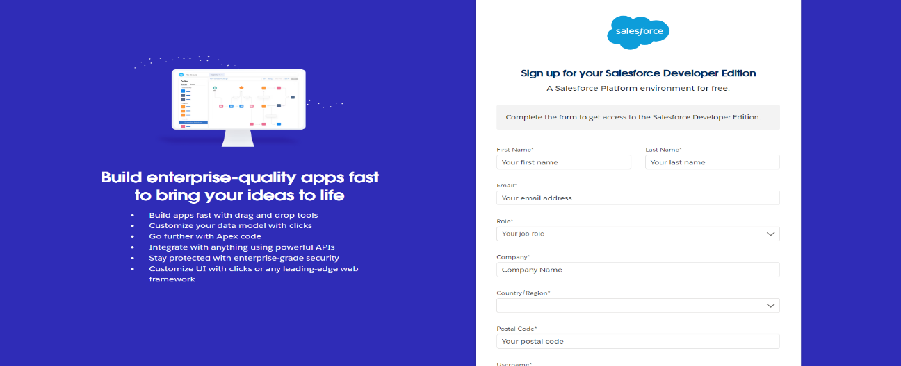

**1.2 Account Activation**

1. Go to the inbox of the email that you used while signing up. Click on the verify account to activate your account. The email may take 5-10mins.

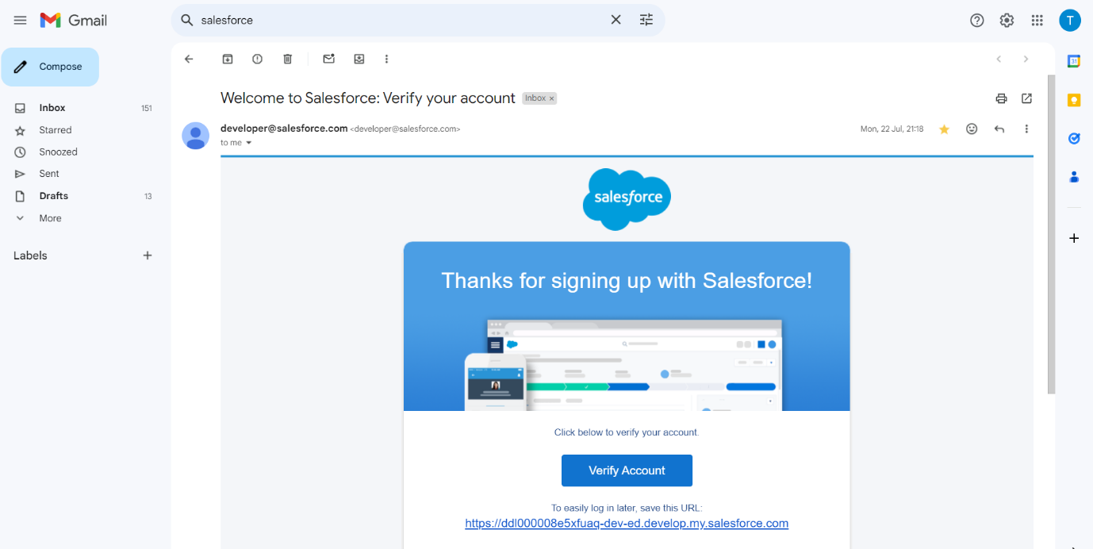2. Click on Verify Account

3. Give a password and answer a security question and click on change password.

4. when you will redirect to your salesforce setup page.

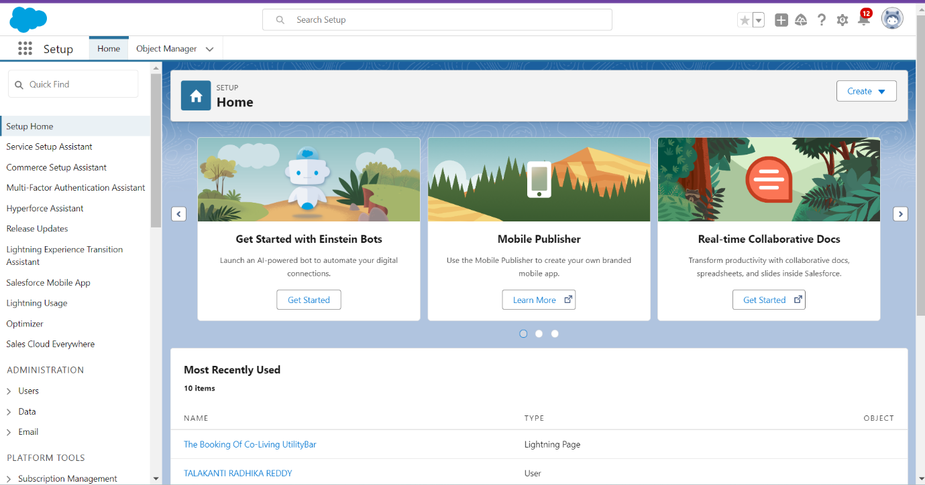

**TASK2: Create Objects**

Salesforce objects are database tables that permit you to store data that is specific to an organization. What are the types of Salesforce objects   
Salesforce objects are of two types:   
  
1. Standard Objects: Standard objects are the kind of objects that are provided by salesforce.com such as users, contracts, reports, dashboards, etc.   
2. Custom Objects: Custom objects are those objects that are created by users. They supply information that is unique and essential to their organization. They are the heart of any application and provide a structure for sharing data.

**2.1 Create a custom object for Total Rooms**

To create a custom object, follow these steps:

1. From setup click on object manager.  
2. Click create, select custom object.

3. Fill in the label as " Total Room ".  
4. Fill in the plural label as " Total Rooms ".  
5. Record name: "Total No Of Rooms"  
6. Select the data type as "Text".  
7. In the Optional Features section, select Allow Reports and Track Field History.  
8. In the Deployment Status section, ensure Deployed is selected.  
9. In the Search Status section, select Allow Search.  
10. In the Object Creation Options section, select Add Notes and Attachments related list to default page layout.

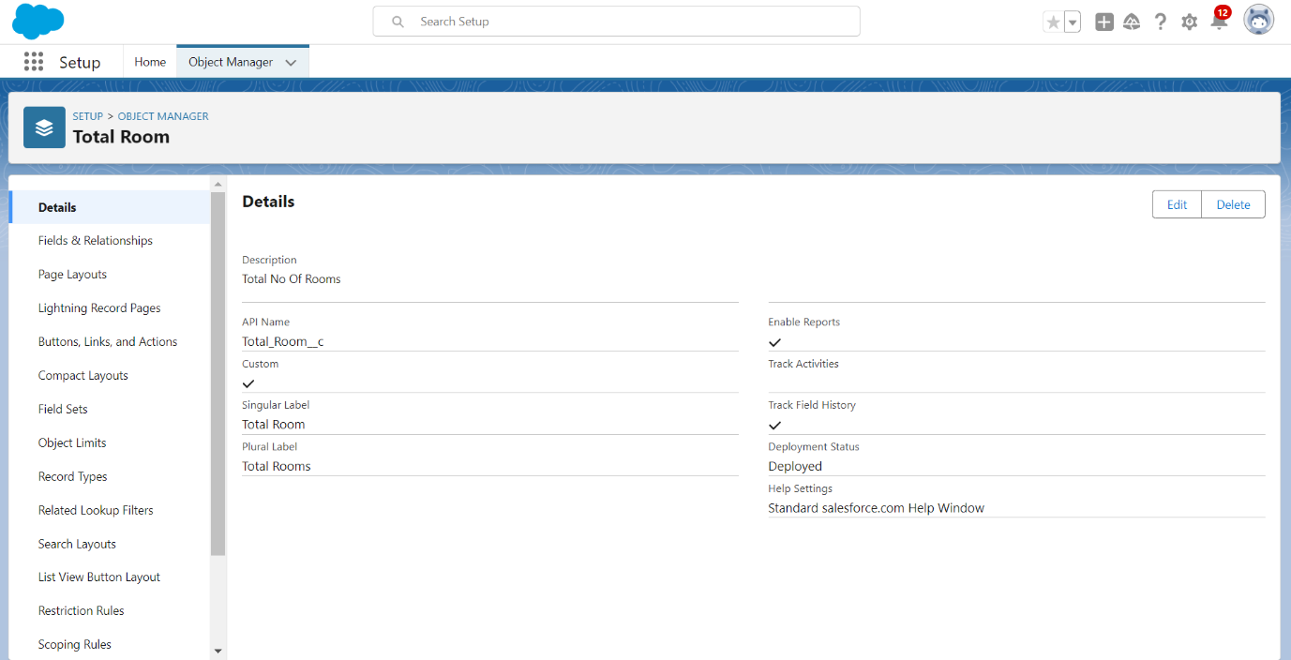

11. Leave everything else as is, and click Save.

**2.2 Create a custom object for Customer**

To create a custom object, follow these steps:

1. From setup click on object manager.
2. Click create, select custom object.
3. Fill in the label as " Customer1 ".
4. Fill in the plural label as " Customers ".
5. Record name: "Customer Name"
6. 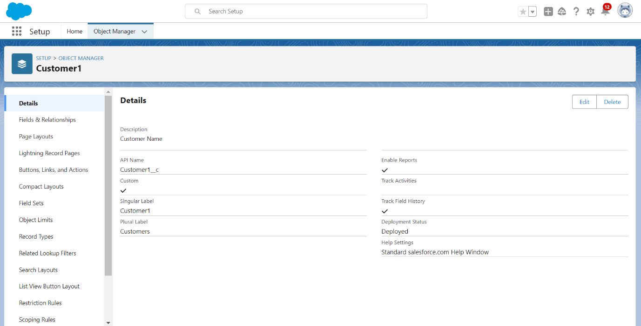Select the data type as "Text".
7. Follow steps 7 to 11 as mentioned for previous object.

**2.3 Create a custom object for Room Booking**

To create a custom object, follow these steps:

1. From setup click on object manager.
2. Click create, select custom object.
3. Fill in the label as " Room Booking ".
4. Fill in the plural label as " Room Bookings ".
5. Record name: "Room No "
6. Select the data type as "Auto number ".
7. Under Display format enter RN-{000}
8. 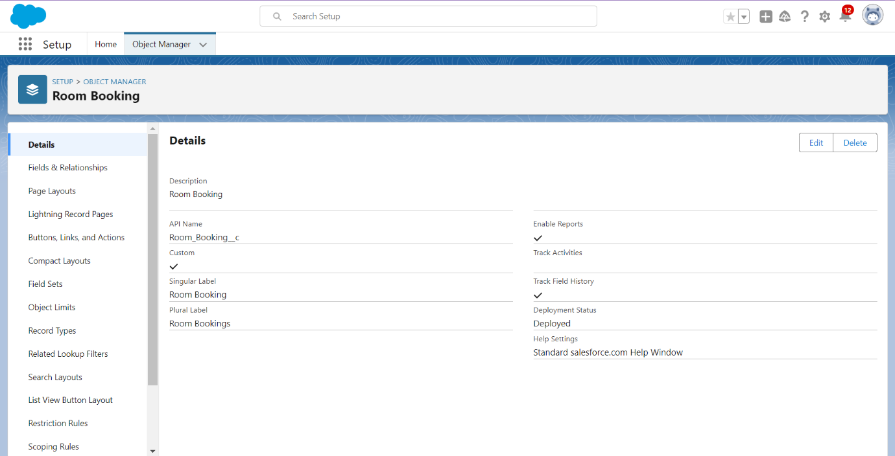Enter starting Number as 1
9. Follow remaining steps as mentioned previously.

**2.4 Create a custom object for Payment**

To create a custom object, follow these steps:

1. From setup click on object manager.
2. 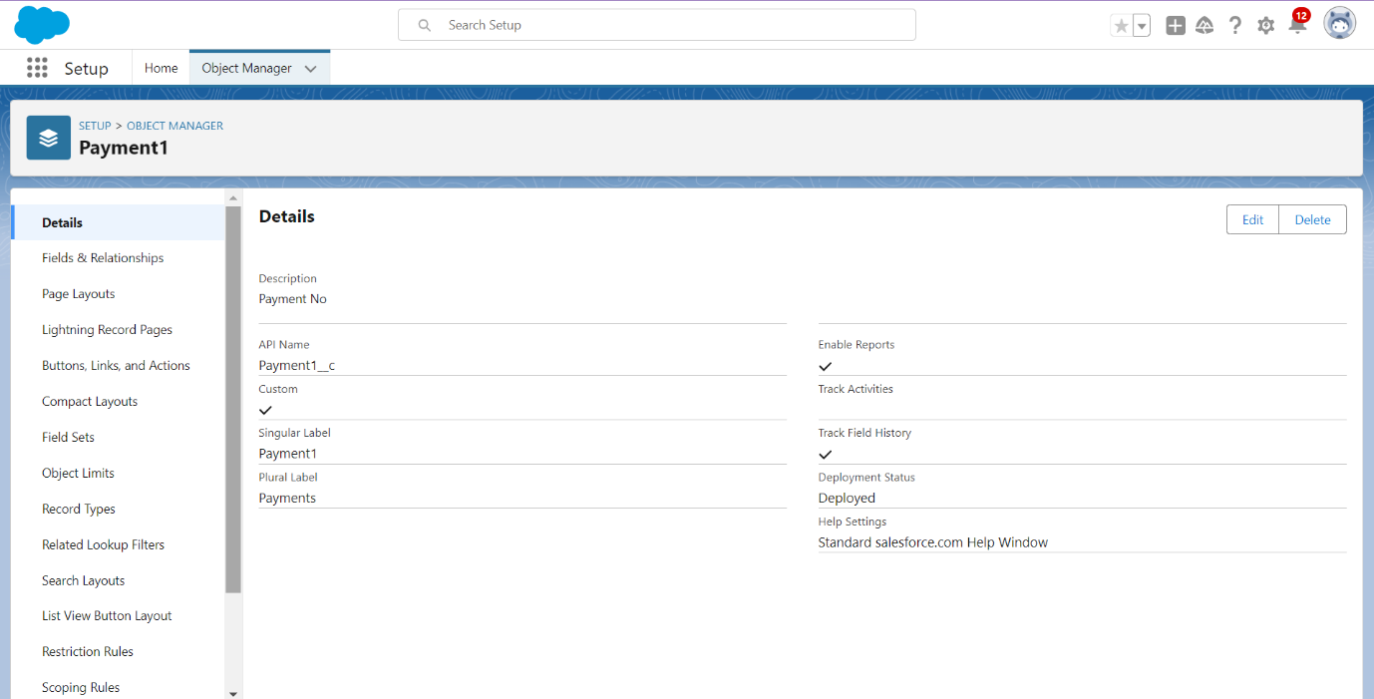Click create, select custom object.
3. Fill in the label as " Payment1".
4. Fill in the plural label as " Payments ".
5. Record name: "Payment No "
6. Select the data type as "Auto number ".
7. Under Display format enter PNO-{000}
8. Enter starting Number as 1
9. Follow remaining steps as mentioned previously.

**2.5 Create a custom object for Food Selection**

To create a custom object, follow these steps:

1. From setup click on object manager.
2. Click create, select custom object.
3. Fill in the label as " Food Selection ".
4. Fill in the plural label as " Food Selections ".
5. Record name: " Food Selection No "
6. Select the data type as "Auto number ".
7. Under Display format enter FS No-{000}
8. 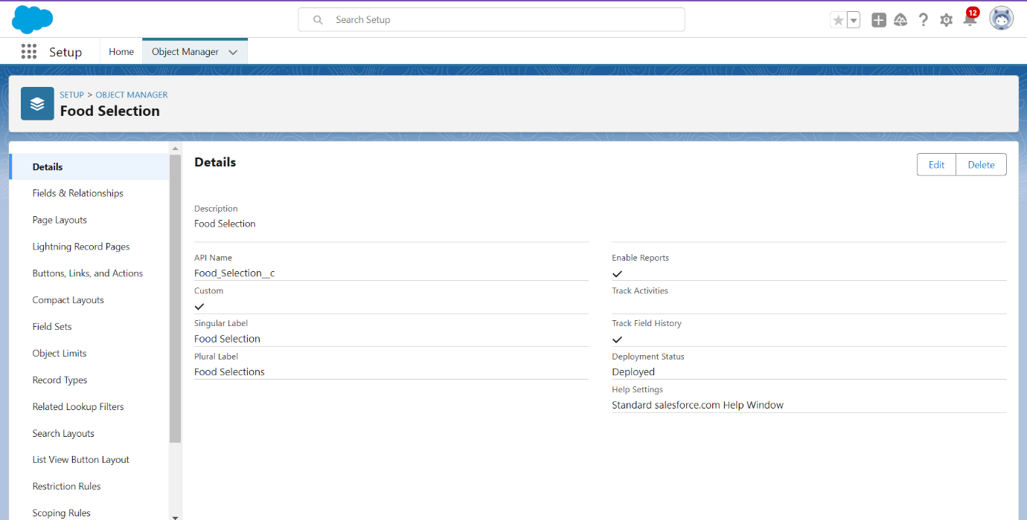Enter starting Number as 1
9. Follow remaining steps as mentioned previously.

**2.6 Create a custom object for Feedback**

To create a custom object, follow these steps:

1. From setup click on object manager.
2. Click create, select custom object.
3. Fill in the label as " Feedback ".
4. Fill in the plural label as " Feedbacks ".
5. Record name: "Feedback No "
6. Select the data type as "Auto number ".
7. Under Display format enter Fd No-{0000}
8. 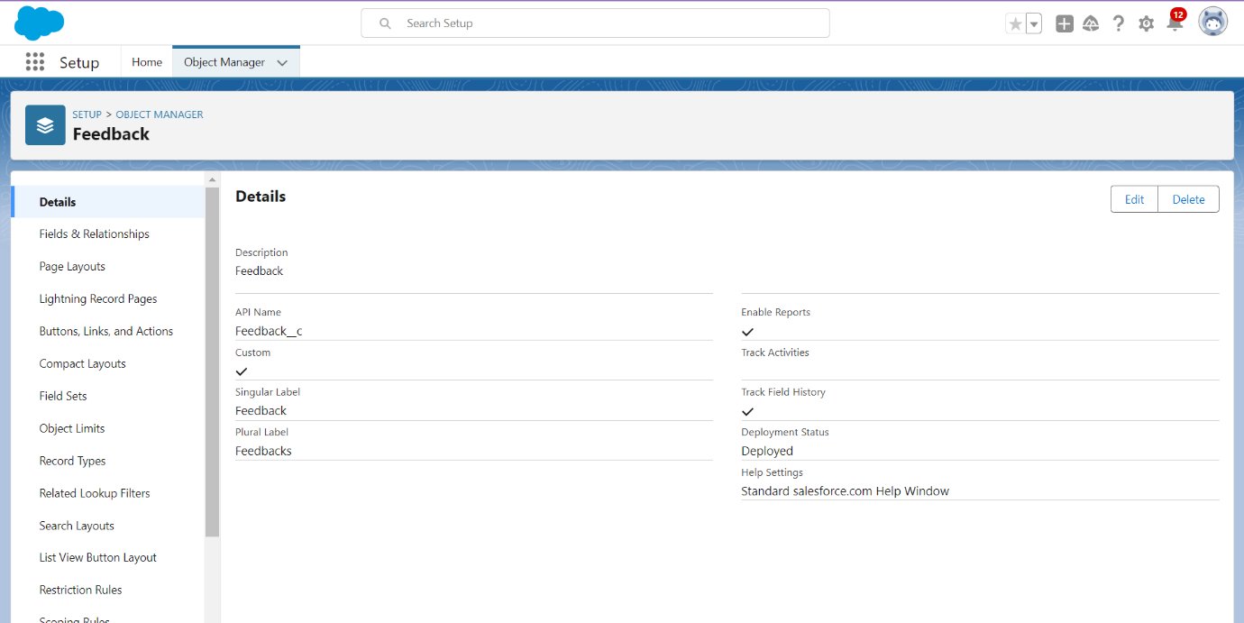Enter starting Number as 1
9. Follow remaining steps as mentioned previously.

**TASK3: Creating Tabs**

A tab is like a user interface that is used to build records for objects and to view the records in the objects.

Types of Tabs:

1. Custom Tabs
2. Web Tabs
3. Visualforce Tabs
4. Lightning Component Tabs
5. Lightning Page Tabs

**3.1 Creating a Tab for Total Rooms**

To create a Tab:(Total Rooms):

1. Go to setup page > type Tabs in Quick Find bar > click on tabs > New (under custom object tab)

2. Select Object(Total Rooms) > Select the tab style.

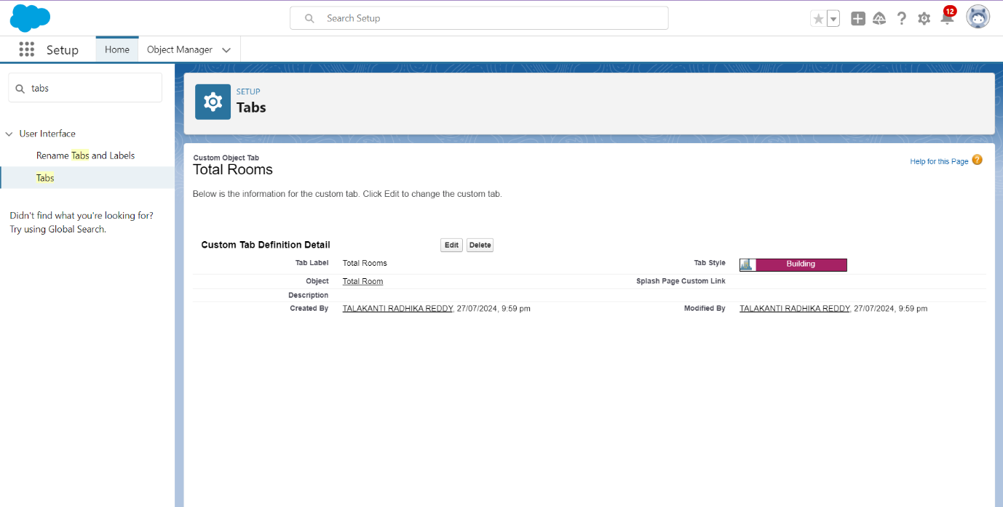3. Next (Add to profiles page) keep it as default

4. Next (Add to Custom App) keep it as default & save.

**3.2 Create a Tab for Customers**

To create a Tab:(Customers)

1. Go to setup page > type Tabs in Quick Find bar > click on tabs > New (under custom object tab)
2. Select Object(Customers) > Select the tab style > Next (Add to profiles page) keep it as default > Next (Add to Custom App) keep it as default > Save.

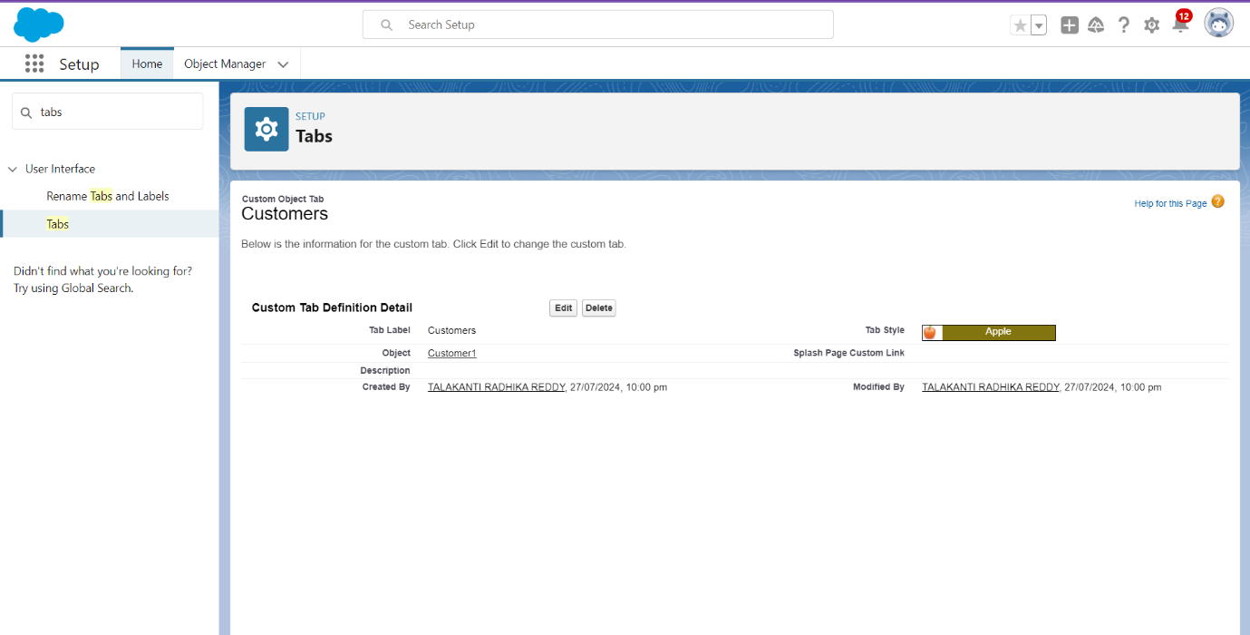

**3.3 To create a Tab for Room Bookings**

To create a Tab:(Room Bookings)

1. Go to setup page > type Tabs in Quick Find bar > click on tabs > New (under custom object tab)
2. 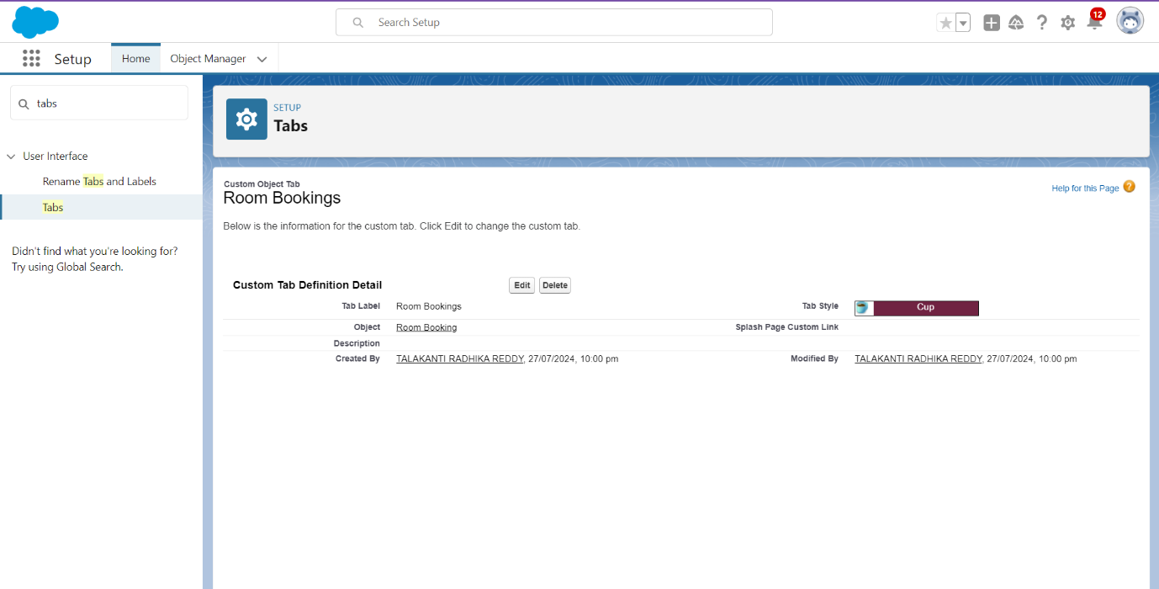Select Object(Room Bookings) > Select the tab style > Next (Add to profiles page) keep it as default > Next (Add to Custom App) keep it as default > Save.

**3.4 Create a Tabs For Remaining Objects**

Now create the tabs for Payments, Food Selections, Feedbacks Objects.

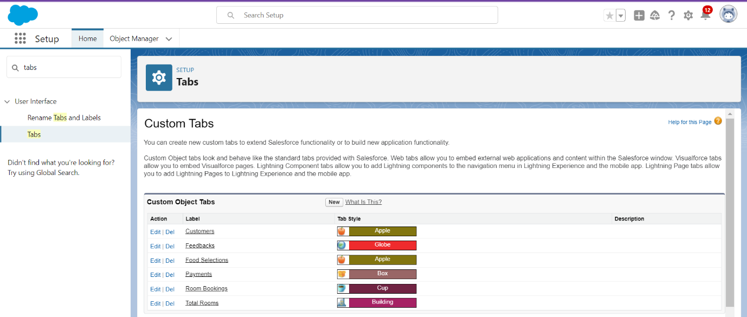

**TASK4: The Lightning App**

An app is a collection of items that work together to serve a particular function. In Lightning Experience, Lightning apps give your users access to sets of objects, tabs, and other items all in one convenient bundle in the navigation bar.

Lightning apps let you brand your apps with a custom color and logo. You can even include a utility bar and Lightning page tabs in your Lightning app. Members of your org can work more efficiently by easily switching between apps.

**4.1 Create a Lightning App**

1. Go to setup page > search “app manager” in quick find > select “app manager” > click on New lightning App.

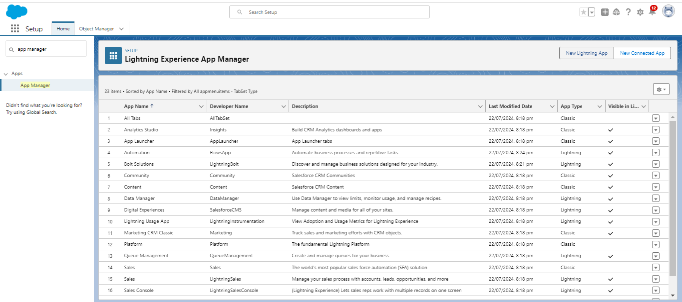  
2. Fill the app name in app details and branding > Next  > (App option page) keep it as default > Next > (Utility Items) keep it as default > Next.

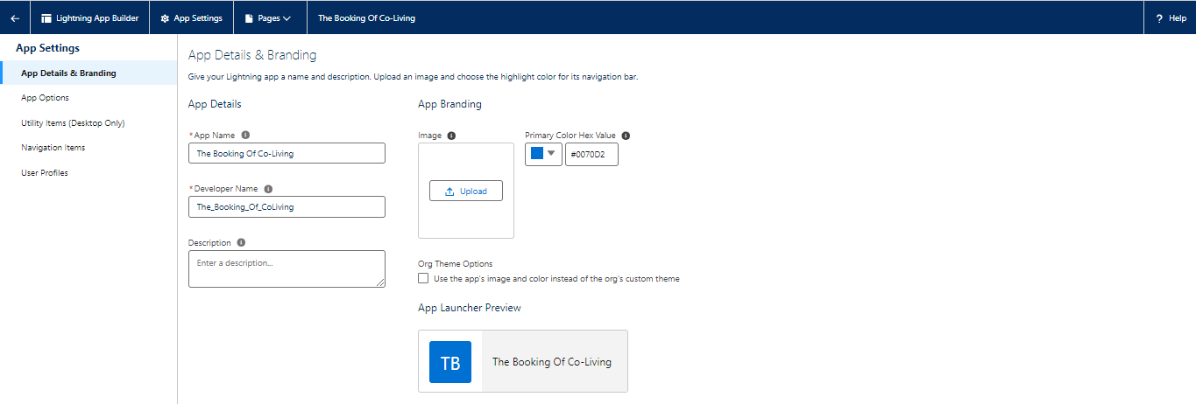

3. To Add Navigation Items: Ctrl and Select the items (Total Rooms, Customers1, Room Booking, Payments1, Food selection, Feedbacks, Reports and Dashboards) from the search bar and move it using the arrow button > Next.

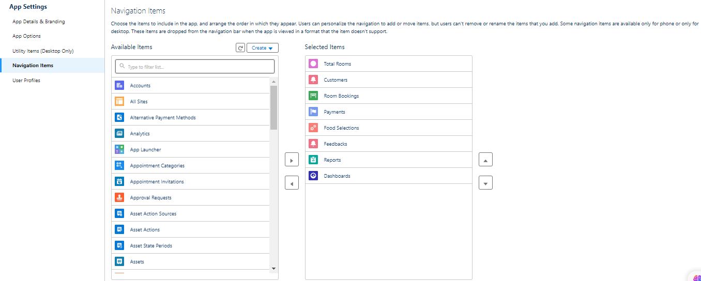  
4. To Add User Profiles:

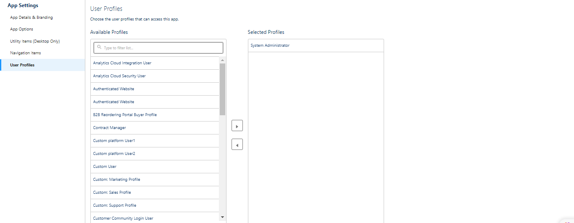

5. Search profiles (System administrator) in the search bar > click on the arrow button > save & finish.

**TASK5: Fields & Relationships**

When we talk about Salesforce, Fields represent the data stored in the columns of a relational database. It can also hold any valuable information that you require for a specific object. Hence, the overall searching, deletion, and editing of the records become simpler and quicker.

Types of Fields

1. Standard Fields
2. Custom Fields

**Standard Fields:**

As the name suggests, the Standard Fields are the predefined fields in Salesforce that perform a standard task. The main point is that you can’t simply delete a Standard Field until it is a non-required standard field. Otherwise, users have the option to delete them at any point from the application freely. Moreover, we have some fields that you will find common in every Salesforce application. They are,

1. Created By

2. Owner

3. Last Modified

4. Field Made During Object Creation

**Custom Fields:**

On the other side of the coin, Custom Fields are highly flexible, and users can change them according to requirements. Moreover, each organizer or company can use them if necessary. It means you need not always include them in the records, unlike Standard fields. Hence, the final decision depends on the user, and he can add/remove Custom Fields of any given form.

### **5.1 Creation of fields for the customer1 object**

**5.1.1 To create fields in an object:**1. Go to setup > click on Object Manager > type object name(Customer1) in search bar > click on the object.

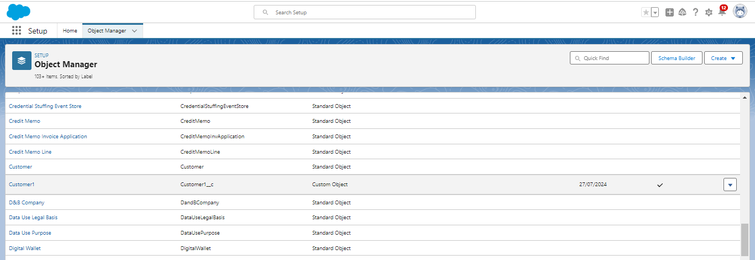

2. Now click on “Fields & Relationships” > New  
3. Select Data Type as a “Phone”  
4. Click on next  
5. Fill the Above as following:

1. Field Label: Phone no
2. Field Name : gets auto generated
3. Click on Next > Next > Save and new.

**5.1.2 To create another fields in an object:**

1. Go to setup > click on Object Manager > type object name(Customer1) in search bar > click on the object.
2. Now click on “Fields & Relationships” > New
3. Select Data type as a “Email” and Click on Next
4. Fill the Above as following:

* Field Label: Email
* Field Name :It’s  gets auto generated
* Click on Next > Next > Save and new.

**5.1.3 To create another fields in an object:**

1. Go to setup > click on Object Manager > type object name(Customer1) in search bar > click on the object.
2. Now click on “Fields & Relationships” ? New
3. Select Data type as a “Text Area” and Click on Next
4. Fill the Above as following:

* Field Label: Permanent Address
* Field Name : It’s gets auto generated
* Click on Next > Next > Save and new.

**5.1.4 To create another fields in an object:**

1. Go to setup > click on Object Manager > type object name(Customer1) in search bar > click on the object.
2. Now click on “Fields & Relationships” > New
3. Select Data type as a “Picklist” and Click on Next
4. Fill the Above as following:

* Field Label: Current Status
* Value - Select enter values with each value separated by a new line

1. Student
2. Employee
3. Others

* Select required
* Field Name :It’s gets auto generated
* Click on Next > Next > Save and new.

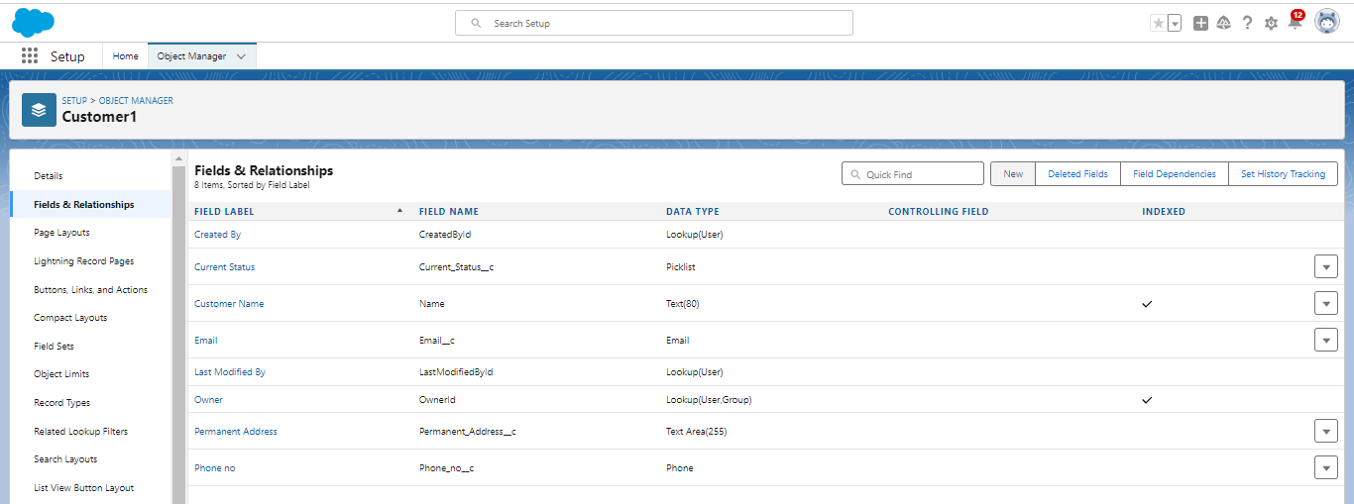

**5.2 Creation of fields for the Room Booking object**

**5.2.1 To create fields in an object:**

* 1.Go to setup > click on Object Manager > type object name(Room Booking) in the search bar > click on the object.
* 2.Now click on “Fields & Relationships” > New
* Select Data Type as a “Picklist”
* Click on Next
* Fill the Above as following:
* Field Label: Room Sharing
* Value - Select enter values with each value separated by a new line

1. Single sharing
2. Double sharing
3. Triple sharing

* Select required
* Click on Next > Next > Save and new.

**5.2.2 To Create a Fields & Relationship to an Room Booking Object**

To create fields & relationship to an object:

1. Go to setup > click on Object Manager > type object name(Room Booking) in the search bar > click on the object.

2. Now click on “Fields & Relationships” > New

3. Select Data Type as a “Master-detail Relationship”

4. Click on Next

5. Click on the Related to drop down and Select the “Customer1” object and click on Next

6. Fill the Above as following:

* Change the Field Label: Name
* Field Name : It’s gets auto generated
* Click on Next > Next > Save and new.

**5.2.3 To create fields in an object:**

1. Go to setup > click on Object Manager > type object name(Room Booking) in the search bar > click on the object.
2. Now click on “Fields & Relationships” > New
3. Select Data Type as a “Checkbox”
4. Click on Next
5. Fill the Above as following:

* Field Label: AC-3000
* Field Name :It’s gets auto generated
* Click on Next > Next > Save and new

**5.2.4 To create fields in an object:**

1. Go to setup > click on Object Manager > type object name(Room Booking) in the search bar > click on the object.
2. Now click on “Fields & Relationships” > New
3. Select Data Type as a “Checkbox”
4. Click on Next
5. Fill the Above as following:

* Field Label: Advance Payment for 1 Month
* Field Name :It’s gets auto generated
* Click on Next > Next > Save and new

**5.2.5 To create fields in an object:**

1. Go to setup ? click on Object Manager ? type object name(Room Booking) in the search bar ? click on the object.
2. Now click on “Fields & Relationships” ? New
3. Select Data Type as a “Currency”
4. Click on Next
5. Fill the Above as following:

* Field Label: Amount
* Length: (18,0)
* Field Name :It’s gets auto generated
* Click on Next > Next > Save and new

**5.2.6 To Create a Fields & Relationship to an Object**

1. Go to setup > click on Object Manager > type object name(Room Booking) in the search bar > click on the object.
2. Now click on “Fields & Relationships” ? New
3. Select Data Type as a “Master-detail Relationship”
4. Click on Next

5. Click on the Related to drop down and Select the “Total Rooms” object and click on Next

* Fill the Above as following:
* Change the Field Label: Total No Of Rooms
* Field Name :It’s gets auto generated
* Click on Next > Next > Save and new.

**5.2.7 To Create a Rollup Summary Field in “Total Room Object”**

1. After Creating the Master- Detail Relationship Than Only you can create the Rollup Summary
2. Go to setup > click on Object Manager > type object name(Total Rooms) in the search bar > click on the object.
3. Now click on “Fields & Relationships” ? New
4. Select Data type as a “Roll-up Summary” and Click on Next

* Fill the Above as following:
* Field Label: Rooms Booked
* Field Name :It’s gets auto generated
* Click on Next

5. Select the Room Bookings in the Summarized Object

6. Select the count Radio button in the select Roll-up Type

7. Click on Next > Next > Save and new

**5.2.8 To create fields in an object:**

1. Go to setup > click on Object Manager > type object name(Rooms Booking) in the search bar > click on the object.
2. Now click on “Fields & Relationships” > New
3. Select Data type as a “Formula” and Click on Next
4. Fill the Above as following:

* Field Label: Rooms Available
* Field Name : It’s gets auto generated
* Select the Formula Return Type as “Number”
* Select the Decimal places as “0” and Click on Next
* Click on the Advanced Formula and Enter the value in formula box “ 30 - ” and Click on insert field than you will find a pop window under the Room Booking select the Total No Of Rooms in the second Column and select the Room Booked in the third column and click on insert “ 30  -  Total_No_Of_Rooms__r.Rooms_Booked__c ” and Check Syntax
* Click on Next > Next > Save and new.

**5.2.9 To create fields in an object:**

1. Go to setup > click on Object Manager > type object name(Room Booking) in the search bar > click on the object.
2. Now click on “Fields & Relationships” > New
3. Select Data Type as a “Checkbox”
4. Click on Next
5. Fill the Above as following:

* Field Label: Check in
* Field Name: It’s gets auto generated
* Click on Next > Next > Save and new

**5.2.10 To create fields in an object:**

1. Go to setup > click on Object Manager > type object name(Room Booking) in the search bar > click on the object.
2. Now click on “Fields & Relationships”? New
3. Select Data Type as a “Checkbox”
4. Click on Next
5. Fill the Above as following:

* Field Label: Check Out
* Field Name: It’s gets auto generated
* Click on Next > Next > Save and new

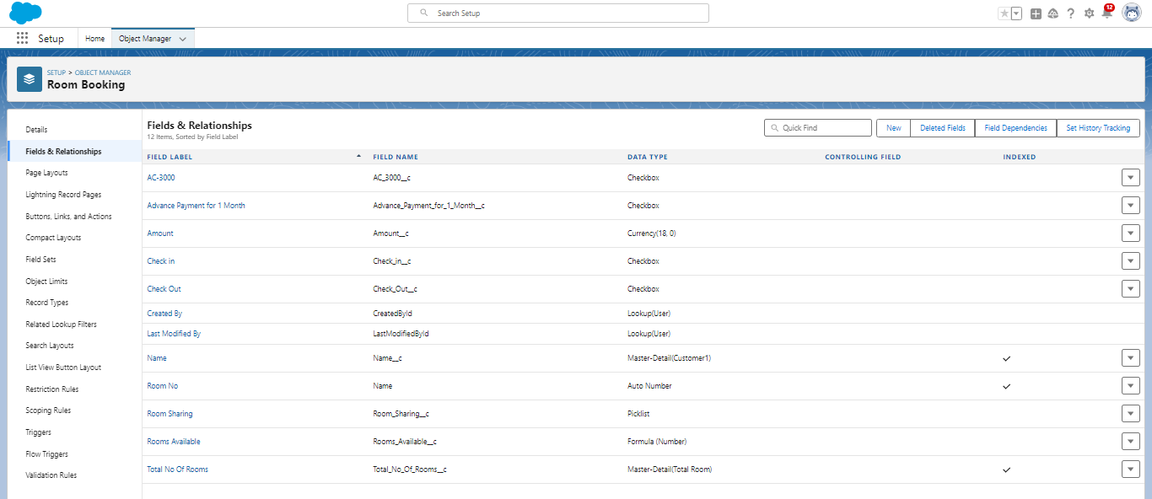

### **5.3 Creation of Fields & Relationship for Payment1 Object**

**5.3.1 To create fields & relationship to an object:**

* Go to setup > click on Object Manager > type object name(Payment1) in the search bar > click on the object.
* Now click on “Fields & Relationships” > New
* Select Data Type as a “Master-detail Relationship”
* Click on Next
* Click on the Related to drop down and Select the Customer1 object and click on Next
* Fill the Above as following:
* Change the Field Label: Name
* Field Name :It’s gets auto generated
* Click on Next > Next > Save and new.

**5.3.2 To create another fields & relationship to an object:**

* Go to setup > click on Object Manager > type object name(Payment1) in the search bar > click on the object.
* Now click on “Fields & Relationships” > New
* Select Data Type as a “Lookup Relationship”
* Click on Next
* Click on the Related to drop down and Select the Room Booking object and click on Next
* Fill the Above as following:
* Change the Field Label: Room Booking
* Field Name: It’s gets auto generated
* Click on Next > Next > Save and new.

**5.3.3 Creation of other fields for the Payment1 object**

To create fields in an object:

* Go to setup > click on Object Manager > type object name(Payment1) in the search bar > click on the object.
* Now click on “Fields & Relationships” > New
* Select Data Type as a “Picklist”
* Fill the Above as following:
* Field Label: Payment Mode
* Value - Select enter values with each value separated by a new line

1. Cash
2. Check
3. Credit card
4. Debit card
5. UPI
6. Phonepe
7. Gpay
8. Paytm

* Select required
* Click on Next > Next > Save and new.

**Cross Object Formula Field:**

In Salesforce, a cross-object formula field allows you to create a formula that references fields from related objects. It enables you to perform calculations or display data from related records without the need for custom code or complex workflows.

**5.3.4. Create a Cross-object formula Field in Payment1 Object**

Go to setup > click on Object Manager > type object name(Payment1) in the search bar > click on the object.

* Now click on “Fields & Relationships” > New
* Select Data Type as a “Formula”
* Click on Next
* Enter the Field label: Amount and Field name: gets auto generated and click on Next
* In the Advanced Formula Click on the Insert field in the popup Screen Select the Payment1 and in the second drop down select the Room Booking and in the three drop down select the Amount field and click on Insert “ Room_Booking__r.Amount__c ”.
* Click on the Check syntax: No syntax errors in merge fields
* Click on Next > Next > Save and new.

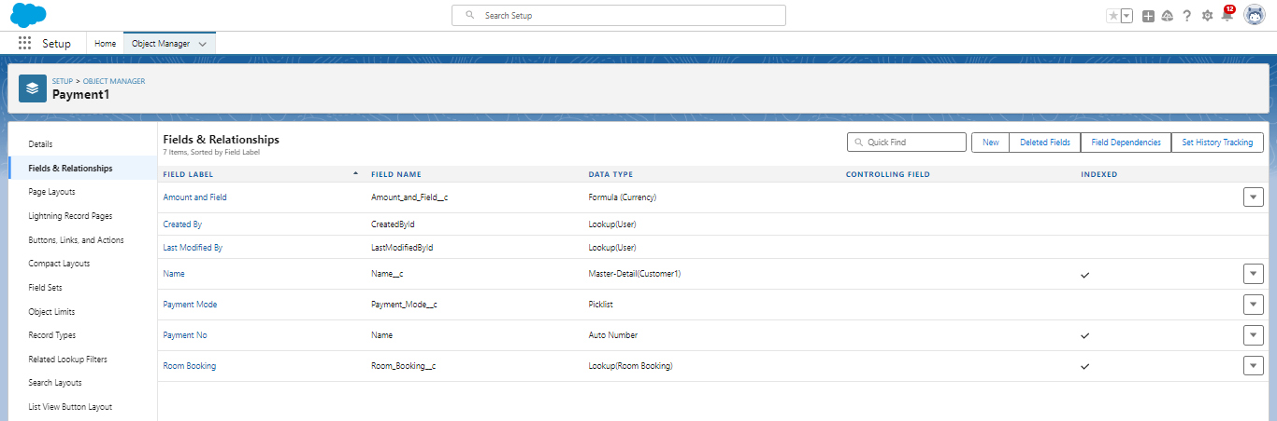

### **5.4. Creation of fields for the Food Selection object**

**5.4.1 To create fields & relationship to an object:**

1. Go to setup > click on Object Manager > type object name (Room Booking) in the search bar > click on the object.
2. Now click on “Fields & Relationships” > New
3. Select Data Type as a “Master-detail Relationship”
4. Click on Next
5. Click on the Related to drop down and Select the Customer1 object and click on Next
6. Fill the Above as following:

* Change the Field Label: Name
* Field Name :It’s gets auto generated
* Click on Next > Next > Save and new.

**Picklist value sets:**

Global picklist value sets let you share the values across objects. Base custom picklist fields on a global value set to inherit its values.

**Create a picklist value set:**

1. First click on gear icon and click on setup
2. Click on home tab in the Quick find box search for the “Picklist value sets”
3. Click on the Picklist value set and click on new
4. Enter the Label name and API name automatically Generate
5. Enter the values with each value separated by a new line

* Sunday
* Monday
* Tuesday
* Wednesday
* Thursday
* Friday
* Saturday

6. Check the Use first value as default value and Click on save.

**5.4.2 Create a picklist Field for Food selection object**

To create fields in an object:

1. Go to setup > click on Object Manager > type object name(Food Selection) in the search bar > click on the object.
2. Now click on “Fields & Relationships” > New
3. Select Data Type as a “Picklist”
4. Fill the Above as following:

* Field Label: Breakfast
* Under Value - Select the Use global picklist value set
* Under the drop down select the Custom Picklist Values
* Select required
* Click on Next > Next > Save and new.

**5.4.3 Create another picklist Field for Food selection object**

To create fields in an object :

1. Go to setup > click on Object Manager > type object name (Food Selection) in the search bar > click on the object.
2. Now click on “Fields & Relationships” > New
3. Select Data Type as a “Picklist”
4. Fill the Above as following:
   1. Field Label: Select Breakfast
   2. Under Value - Enter values, with each value separated by a new line
5. Idli
6. Bonda
7. Dosa
8. Upma
9. Vada
10. Puri
11. Chapati
    1. Select Checkbox Use First value as default Value
    2. Click on Next > Next > Save and new.

**Field Dependency:**

A field dependency refers to a relationship between two fields on an object where the values of one field determine the available values for another field. Field dependencies are commonly used to create picklist field relationships, where the available options in a dependent picklist are determined by the value selected in a controlling picklist.

**Create a Field Dependency on Breakfast and Select Breakfast Fields in Food Selection Object.**

1. Go to setup > click on Object Manager > type object name(Food Selection) in the search bar > click on the object.
2. Now Click on fields & relationships and Click on Field Dependencies
3. Now Click on New Option
4. Under Controlling Field: Breakfast, Dependent Field: Select Breakfast and Click on Continue
5. Under the Sunday Ctrl and select the Picklist values Idli,Dosa,Puri and Click on Include Values in such a way that do for the remaining days and click on save.

**5.4.4 To create fields in an object:**

1. Go to setup > click on Object Manager > type object name(Food Selection) in the search bar ? click on the object.
2. Now click on “Fields & Relationships” > New
3. Select Data Type as a “Picklist”
4. Fill the Above as following:

* Field Label: Lunch
* Under Value - Select the Use global picklist value set
* Under the drop down select the Custom Picklist Values
* Select required
* Click on Next > Next > Save and new.

**5.4.5 To create fields in an object:**

1. Go to setup > click on Object Manager > type object name(Food Selection) in the search bar > click on the object.
2. Now click on “Fields & Relationships” > New
3. Select Data Type as a “Picklist”
4. Fill the Above as following:

* Field Label: Select Lunch
* Under Value - Enter values, with each value separated by a new line

1. Meals
2. Chicken biryani
3. Veg biryani
4. Veg fried rice
5. Egg fried rice
6. Chicken fried rice
7. Curd rice
8. Tomato rice
9. Egg noodles
10. Chicken Noodles
11. Bhagara rice

* Select Checkbox Use First value as default Value
* Click on Next > Next > Save and new.

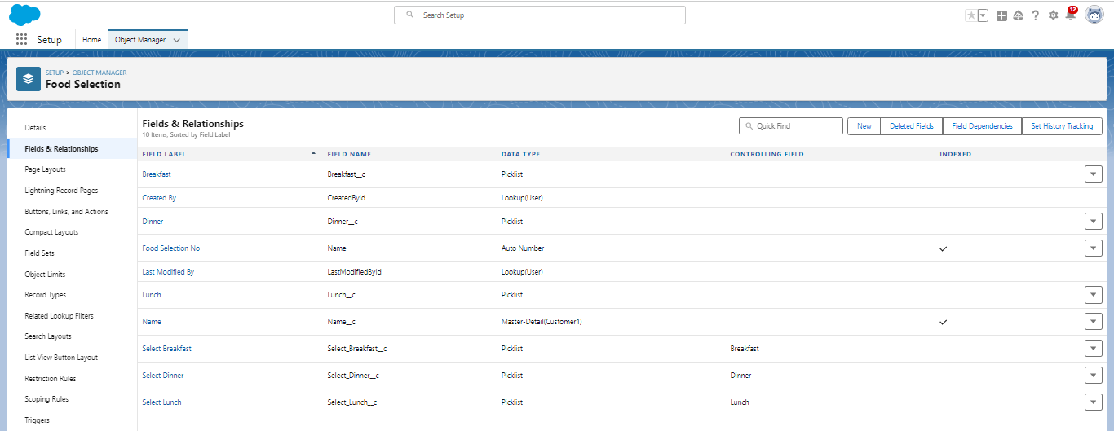

**To create a Field dependency for Lunch and Select Lunch.**

1. Go to setup > click on Object Manager > type object name(Food Selection) in the search bar > click on the object.
2. Now Click on fields & relationships and Click on Field Dependencies
3. Now Click on New Option
4. Under Controlling Field:Lunch, Dependent Field: Select Lunch and Click on Continue
5. Under the Sunday Ctrl and select the Picklist values Chicken biryani, Egg fried rice, curd rice and Click on Include Values in such a way that do for the remaining days and click on save.

**5.4.6 To create fields in an object:**

1. Go to setup > click on Object Manager > type object name(Food Selection) in the search bar > click on the object.
2. Now click on “Fields & Relationships” > New
3. Select Data Type as a “Picklist”
4. Fill the Above as following:

* Field Label: Dinner
* Under Value - Select the Use global picklist value set
* Under the drop down select the Custom Picklist Values
* Select required
* Click on Next > Next > Save and new.

**5.4.7 To create fields in an object:**

1. Go to setup > click on Object Manager > type object name(Food Selection) in the search bar > click on the object.
2. Now click on “Fields & Relationships” > New
3. Select Data Type as a “Picklist”
4. Fill the Above as following:

* Field Label: Select Dinner
* Under Value - Enter values, with each value separated by a new line
  1. Meals
  2. Chicken biryani
  3. Veg biryani
  4. Veg fried rice
  5. Egg fried rice
  6. Chicken fried rice
  7. Curd rice
  8. Tomato rice
  9. Egg noodles
  10. Chicken Noodles
  11. Bhagara rice
* Select Checkbox Use First value as default Value
* Click on Next > Next > Save and new.

**To create a Field dependencies for Dinner and Select Dinner.**

* 1. Go to setup > click on Object Manager > type object name(Food Selection) in the search bar > click on the object.
  2. Now Click on fields & relationships and Click on Field Dependencies
  3. Now Click on New Option
  4. Under Controlling Field: Dinner, Dependent Field: Select Dinner and Click on Continue
  5. Under the Sunday Ctrl and select the Picklist values Chicken biryani, curd rice, Chicken noodles and Click on Include Values in such a way that do for the remaining days and click on save.

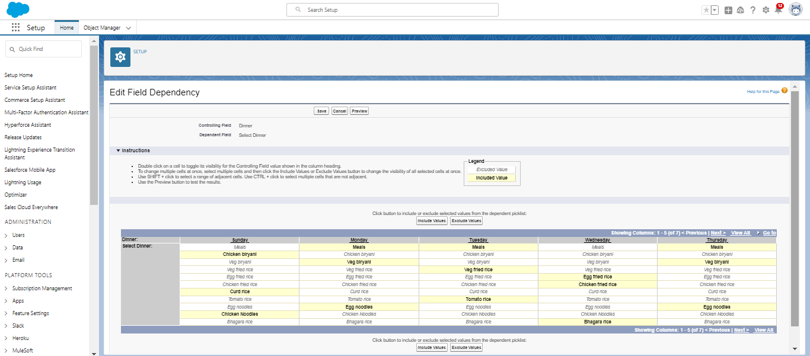

### **5.5. Creation of fields for the Feedback object**

**5.5.1 create fields & relationship to an object:**

1. Go to setup > click on Object Manager > type object name(Feedback) in search bar > click on the object.
2. Now click on “Fields & Relationships” > New
3. Select Data Type as a “Lookup Relationship”
4. Click on Next
5. Click on the Related to drop down and Select the Customer1 object and click on Next
6. Fill the Above as following:

* Change the Field Label: Name
* Field Name: It’s gets auto generated
* Click on Next > Next > Save and new.

**5.5.2 To create other fields in an Same object:**

1. Go to setup > click on Object Manager > type object name (Feedback) in search bar > click on the object.
2. Now click on “Fields & Relationships” > New
3. Select Data Type as a “Picklist”
4. Click on Next
5. Fill the Above as following:

* Field Label: Roomcleaning
* Field Name: It’s gets auto generated
* Under Values select Enter values, with each value separated by a new line

1. Good
2. Satisfaction
3. Bad

* Click on Next > Next > Save and new.

**5.5.3 To create a Another Fields in an Same Object**

1. Go to setup > click on Object Manager > type object name(Feedback) in search bar > click on the object.
2. Now click on “Fields & Relationships” ? New
3. Select Data Type as a “Picklist”
4. Click on Next
5. Fill the Above as following:

* Field Label: Internet
* Field Name: It’s gets auto generated
* Under Values select Enter values, with each value separated by a new line

1. Good
2. Satisfaction
3. Bad

* Click on Next > Next > Save and new.

**5.5.4 To create a Another Fields in an Same Object**

1. Go to setup > click on Object Manager > type object name(Feedback) in search bar > click on the object.
2. Now click on “Fields & Relationships” ? New
3. Select Data Type as a “Picklist”
4. Click on Next
5. Fill the Above as following:

* Field Label: Food
* Field Name: It’s gets auto generated
* Under Values select Enter values, with each value separated by a new line

1. Good
2. Satisfaction
3. Bad

* Click on Next > Next > Save and new.

**5.5.5 To create a Another Fields in an Same Object**

1. Go to setup > click on Object Manager > type object name (Feedback) in search bar > click on the object.
2. Now click on “Fields & Relationships” > New
3. Select Data Type as a “Text area”
4. Click on Next
5. Fill the Above as following:

* Field Label: Suggestion
* Field Name: It’s gets auto generated
* Click on Next > Next > Save and new.

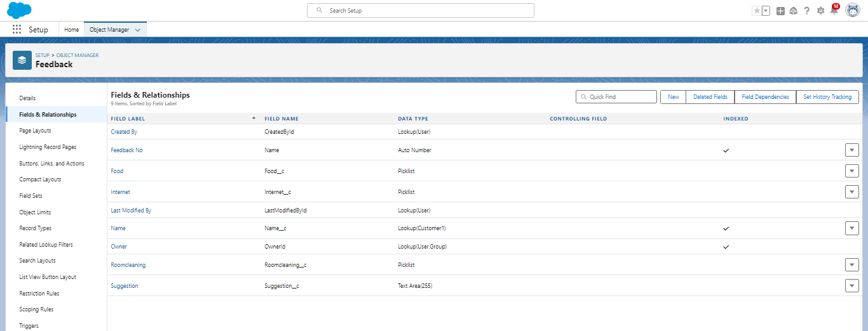

### **5.6. Creation of fields for the Total Rooms object**

**5.6.1 To create fields in an object:**

1. Go to setup > click on Object Manager > type object name(Total Rooms) in search bar > click on the object.
2. Now click on “Fields & Relationships” > New
3. Select Data type as a “Formula” and Click on Next
4. Fill the Above as following:
5. Field Label: Rooms Available
6. Field Name : It’s gets auto generated
7. Select the Formula Return Type as “Number”
8. Select the Decimal places as “0” and Click on Next
9. Note: I am Considering “Total No Of Rooms = 30” While creating a new record in Total Rooms Object.
10. Click on the Advanced Formula “ 30 -  Rooms_Booked__c ” and Check Syntax
11. Click on Next > Next > Save and new.

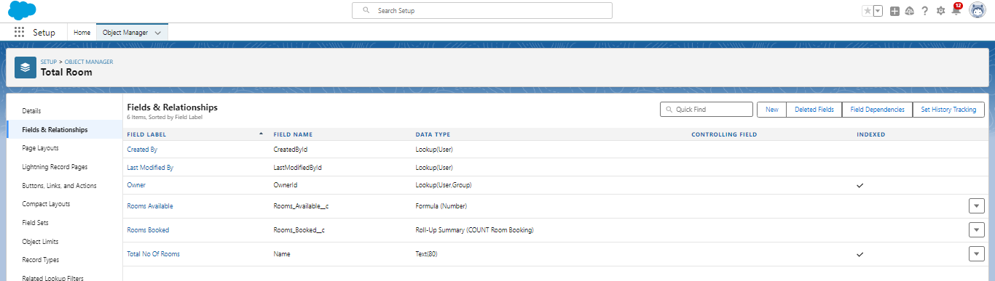

**TASK6: Validation rule**

Validation rules are applied when a user tries to save a record and are used to check if the data meets specified criteria. If the criteria are not met, the validation rule triggers an error message and prevents the user from saving the record until the issues are resolved.

### **6.1 Create a validation rule to a Room Booking Object**

1. Go to setup > click on Object Manager > type object name(Room Booking) in the search bar > click on the object.
2. Now click on “Validation rule” at top > New.
3. Enter Rule name “checkbox field” and make the validation should be Active.
4. Enter the formula in the formula Box “Advance_payment_for_1month__c  = false” and check for syntax error.
5. Enter the error message “Checkbox should be checked”
6. Select error location as field (Advance payment for 1month)
7. Click on save.

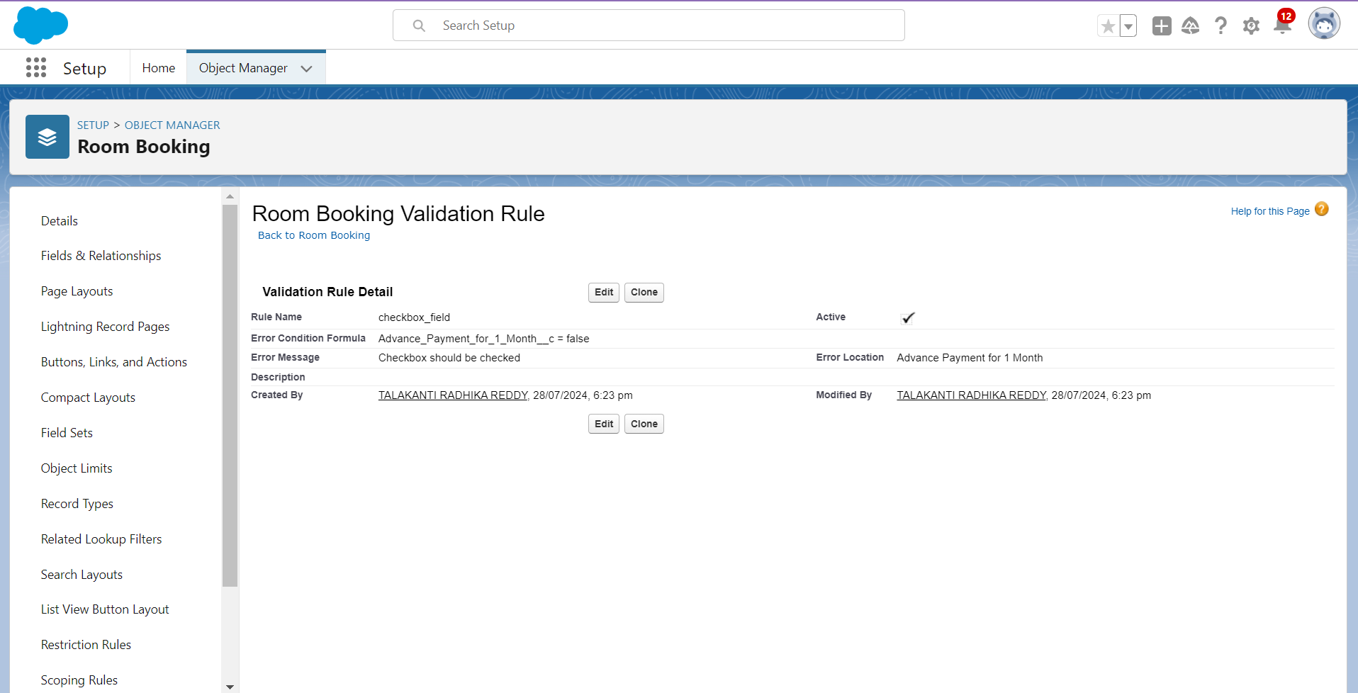

### **6.2 Create a Another validation rule to a Room Booking Object**

1. Go to setup > click on Object Manager > type object name (Room Booking) in the search bar > click on the object.
2. Now click on “Validation rule” at top > New.
3. Enter Rule name “check in rule” and make the validation should be Active.
4. Enter the formula in the formula Box “ Check_in__c = False ” and check for syntax error.
5. Enter the error message “Check box should be checked”
6. Select error location as field(Check in)

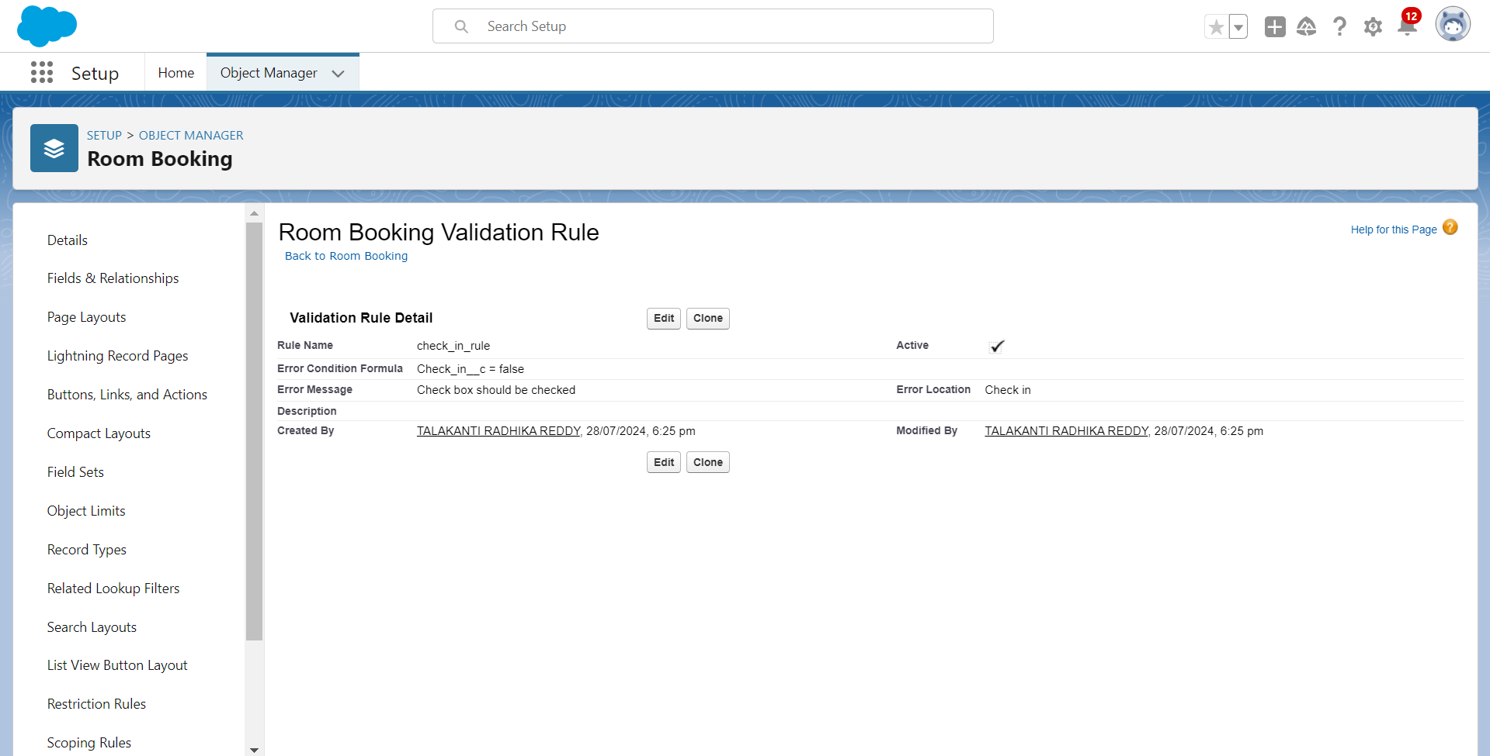

**TASK7: Creating Profiles**

A profile is a group/collection of settings and permissions that define what a user can do in salesforce. Profile controls “Object permissions, Field permissions, User permissions, Tab settings, App settings, Apex class access, Visualforce page access, Page layouts, Record Types, Login hours & Login IP ranges. You can define profiles by the user's job function. For example, System Administrator, Developer, Sales Representative.

Types of profiles in salesforce

1. Standard profiles:

By default, salesforce provides below standard profiles.

* Contract Manager
* Read Only
* Marketing User
* Solutions Manager
* Standard User
* System Administrator.

2. Custom Profiles:

Custom ones defined by us.

They can be deleted if there are no users assigned with that particular one.

**7.1 Custom user Profile**

1. To create a new profile: 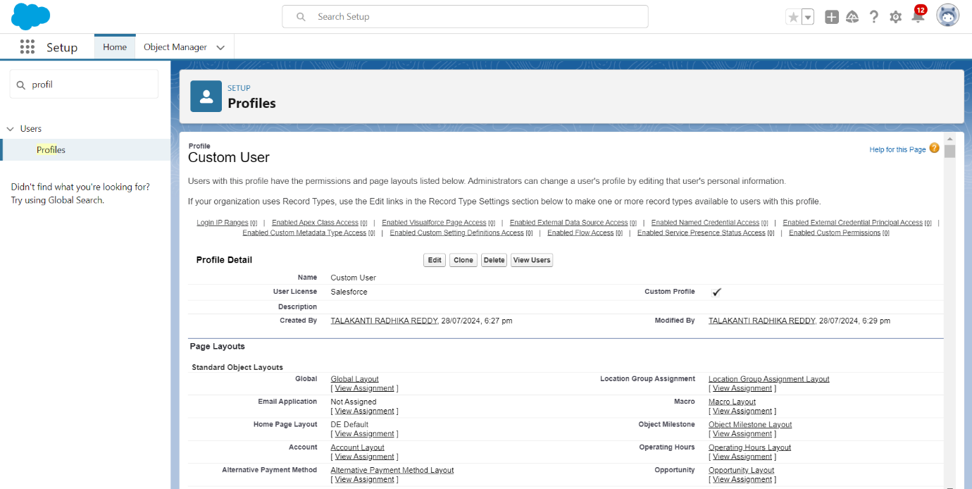Go to setup > type profiles in quick find box > click on profiles > clone the desired profile (Standard User)

2. Enter profile name (Custom User) > Save.

3. While still on the profile page, then click Edit.

4. Scroll down to Custom Object Permissions and Give All access permissions for Customers, Feedbacks, Food selections, Payments, Room Bookings and Total Rooms.

5. Scroll down and Click on Save.

**7.2 Custom platform user1**

To create a new profile:

1. Go to setup > type profiles in quick find box > click on profiles > clone the desired profile (Standard platform User)
2. Enter profile name (Custom platform User1) > Save.
3. While still on the profile page, then click Edit.
4. Scroll down to Custom Object Permissions and Give only Read access permissions for Customers, Feedbacks, Food selections, Payments, Room Bookings and Total Rooms.
5. Scroll down and Click on Save.

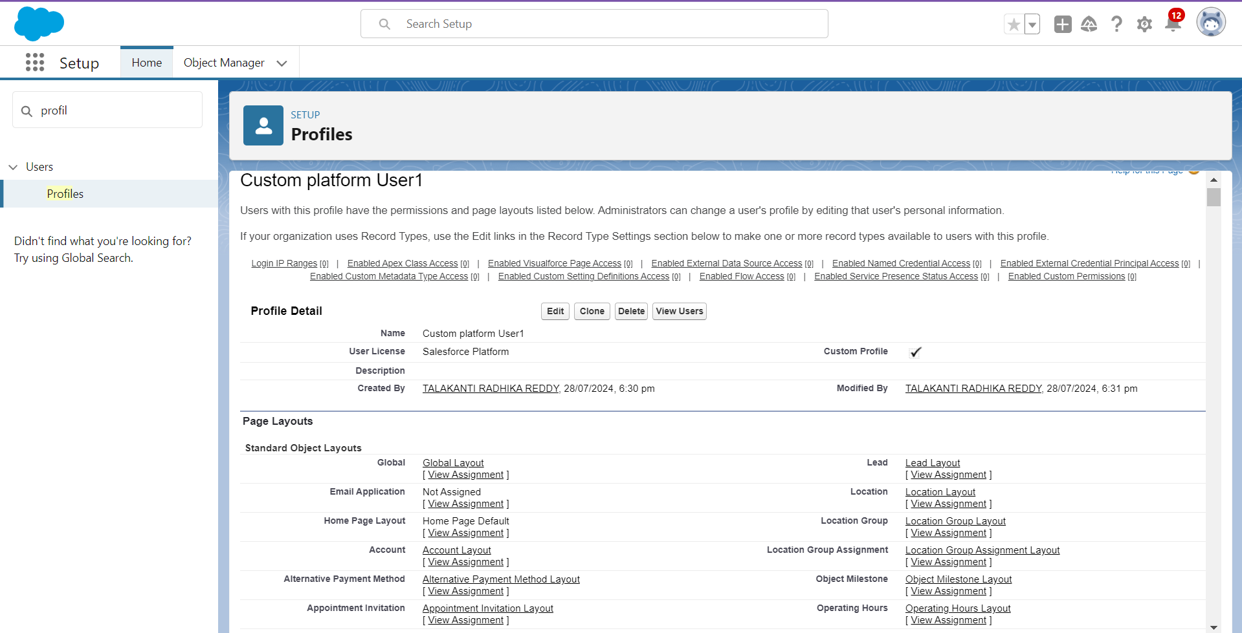

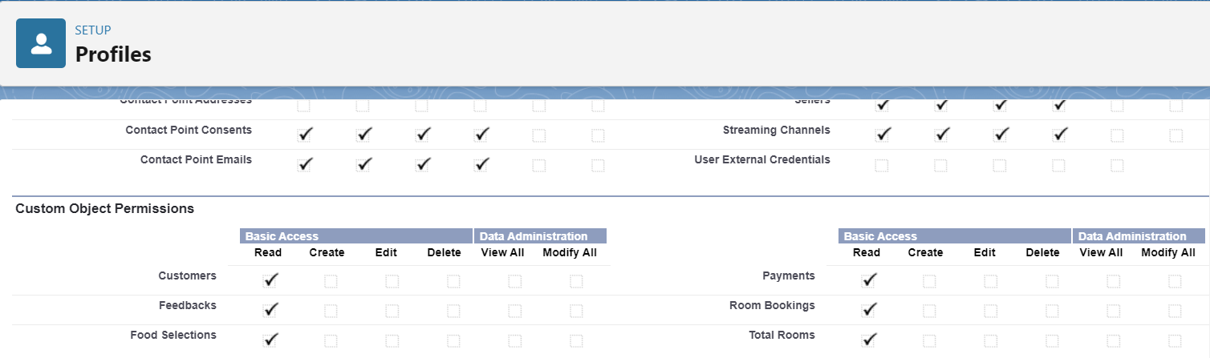

**7.3 Custom platform user2**

To create a new profile:

1. Go to setup > type profiles in quick find box > click on profiles > clone the desired profile (Standard platform User)
2. Enter profile name (Custom platform User2) > Save.
3. While still on the profile page, then click Edit.
4. Scroll down to Custom Object Permissions and Give Create, Read, Edit and Delete access permissions for Customers, Feedbacks, Food selections, Payments and Room Bookings. And Read Access permission for Total Rooms Object.
5. Scroll down and Click on Save.

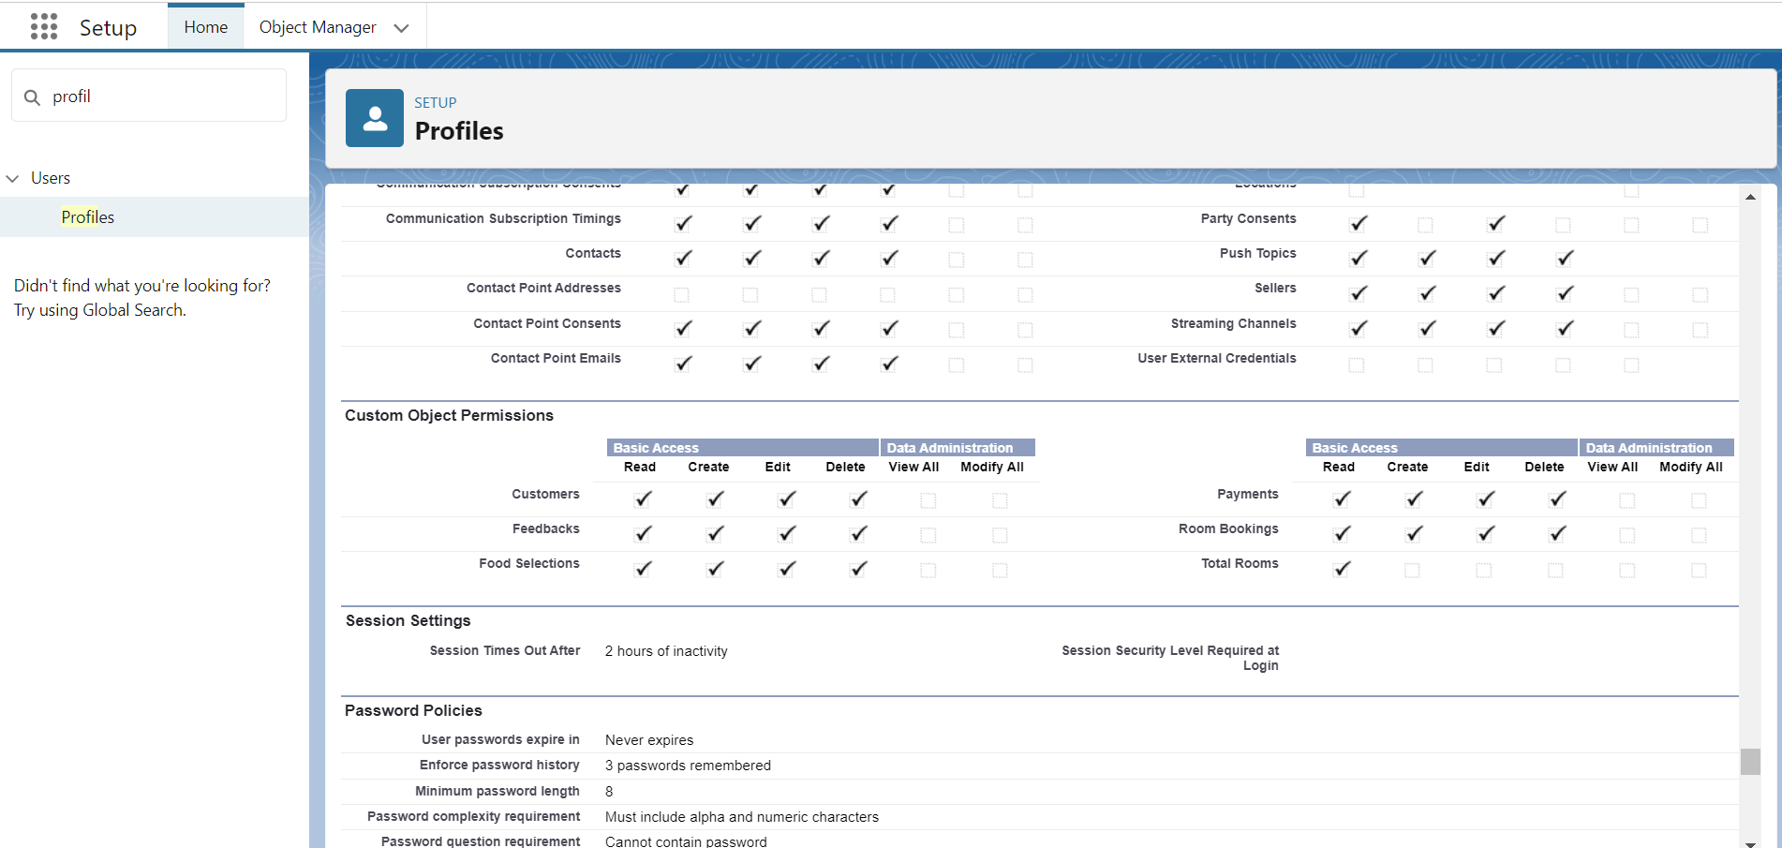

**TASK8: Creating Roles**

A role in Salesforce defines a user's visibility access at the record level. Roles may be used to specify the types of access that people in your Salesforce organization can have to data. Simply put, it describes what a user could see within the Salesforce organization.

* 1. **Marketing Role**

1. Go to quick find > Search for Roles > click on set up roles.
2. Click on Expand All and click on add role under CEO role.
3. Give Label as “Marketing” and Role name gets auto populated.
4. Then click on Save.

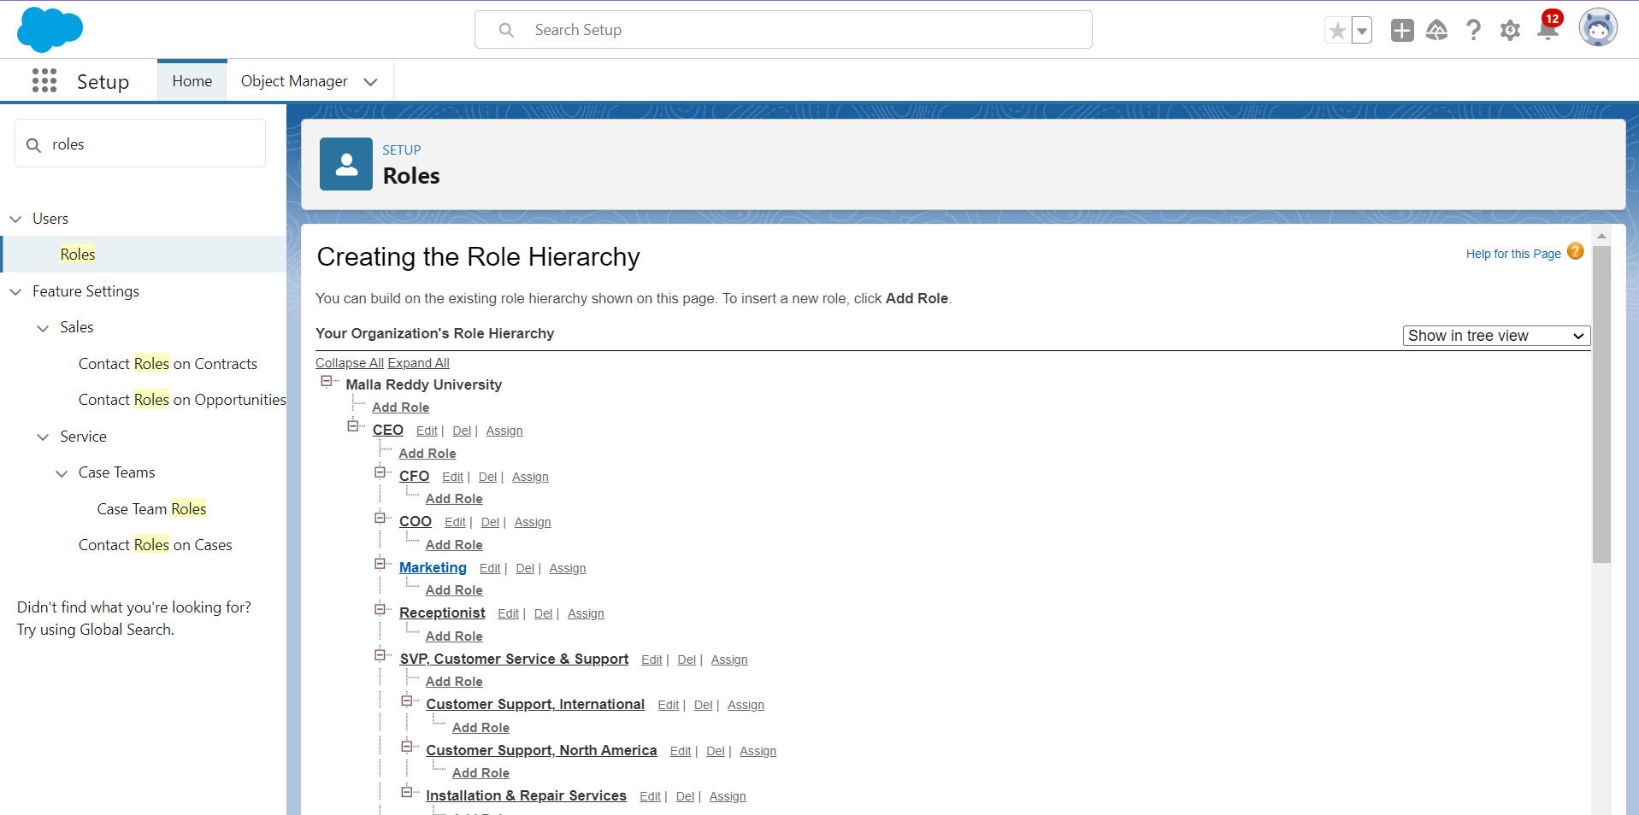

**8.2 Receptionist Role**

1. Go to quick find > Search for Roles > click on set up roles.
2. Click on Expand All and click on add role under CEO role.
3. Give Label as “Receptionist” and Role name gets auto populated.
4. Then click on Save.

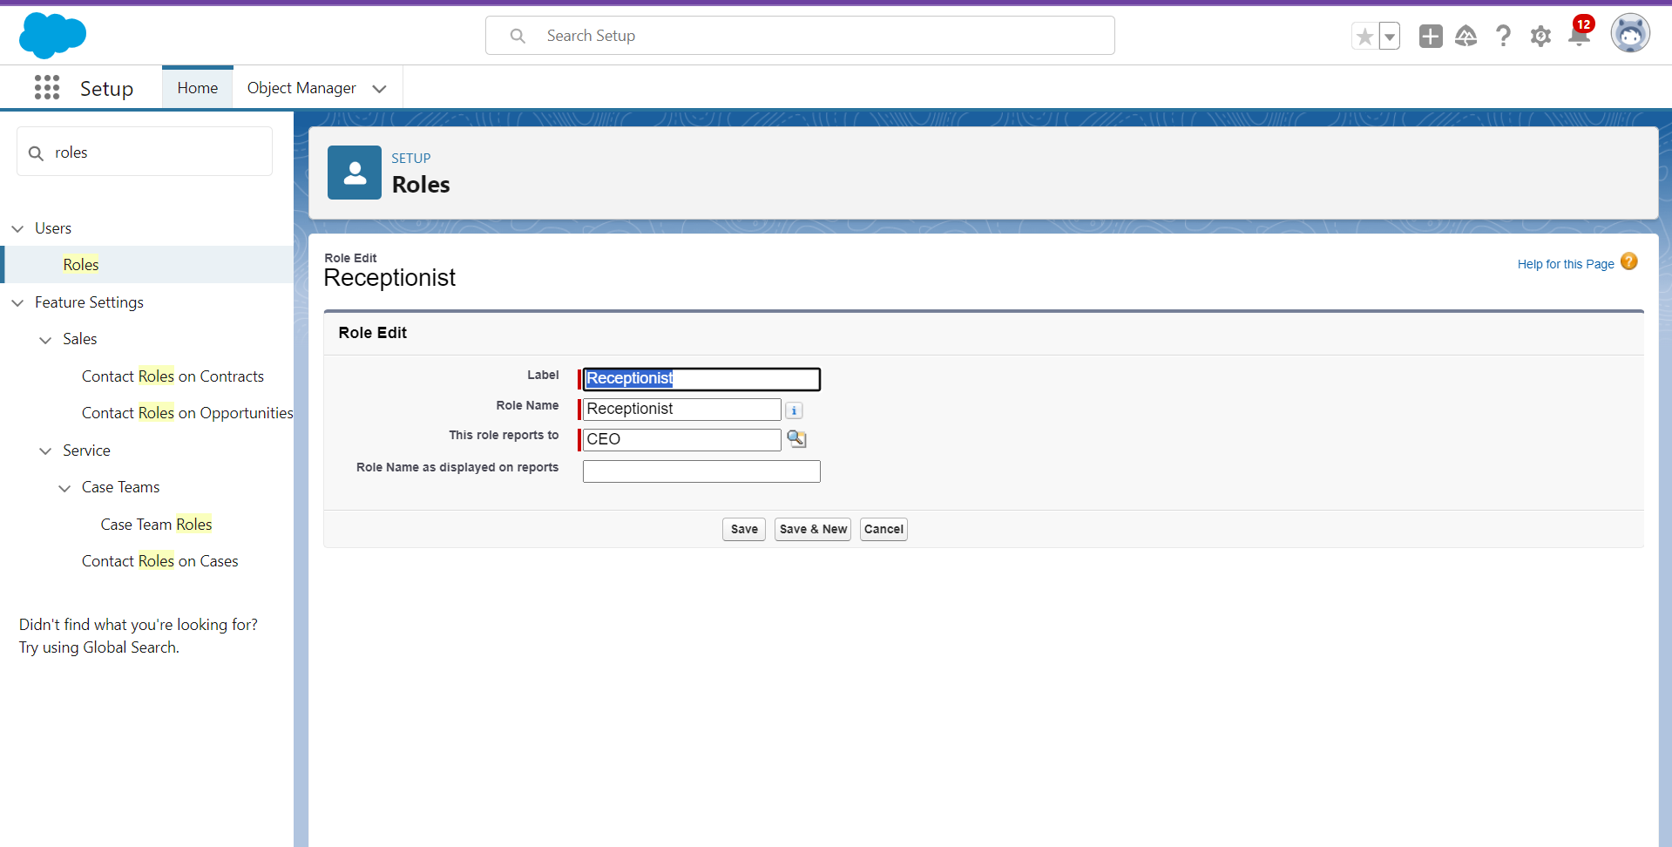

**TASK9: Users**

A user is anyone who logs in to Salesforce. Users are employees at your company, such as sales reps, managers, and IT specialists, who need access to the company's records. Every user in Salesforce has a user account. The user account identifies the user, and the user account settings determine what features and records the user can access.

**9.1 Create User**

1. Go to setup > type users in quick find box > select users > click New user.
2. Fill in the fields

* First Name : sandeep
* Last Name : gujja
* Alias : Give a Alias Name
* Email id : Give your Personal Email id
* Username : Username should be in this form: text@text.com
* Nick Name : Give a Nickname
* Role   : CEO
* User licence : Salesforce
* Profiles   : Custom user

1. save.

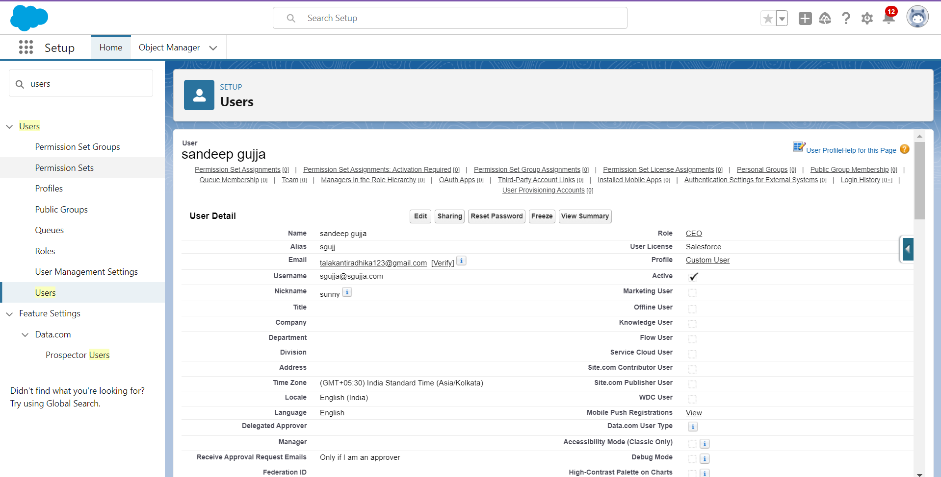

**9.2 Create Another User**

1. Go to setup > type users in quick find box > select users > click New user.
2. Fill in the fields

* First Name : Abhilash
* Last Name : garapati
* Alias           : Give a Alias Name
* Email id : Give your Personal Email id
* Username : Username should be in this form: text@text.com
* Nick Name : Give a Nickname
* Role : Marketing
* User licence: Salesforce platform
* Profiles : Custom Platform User1

1. save

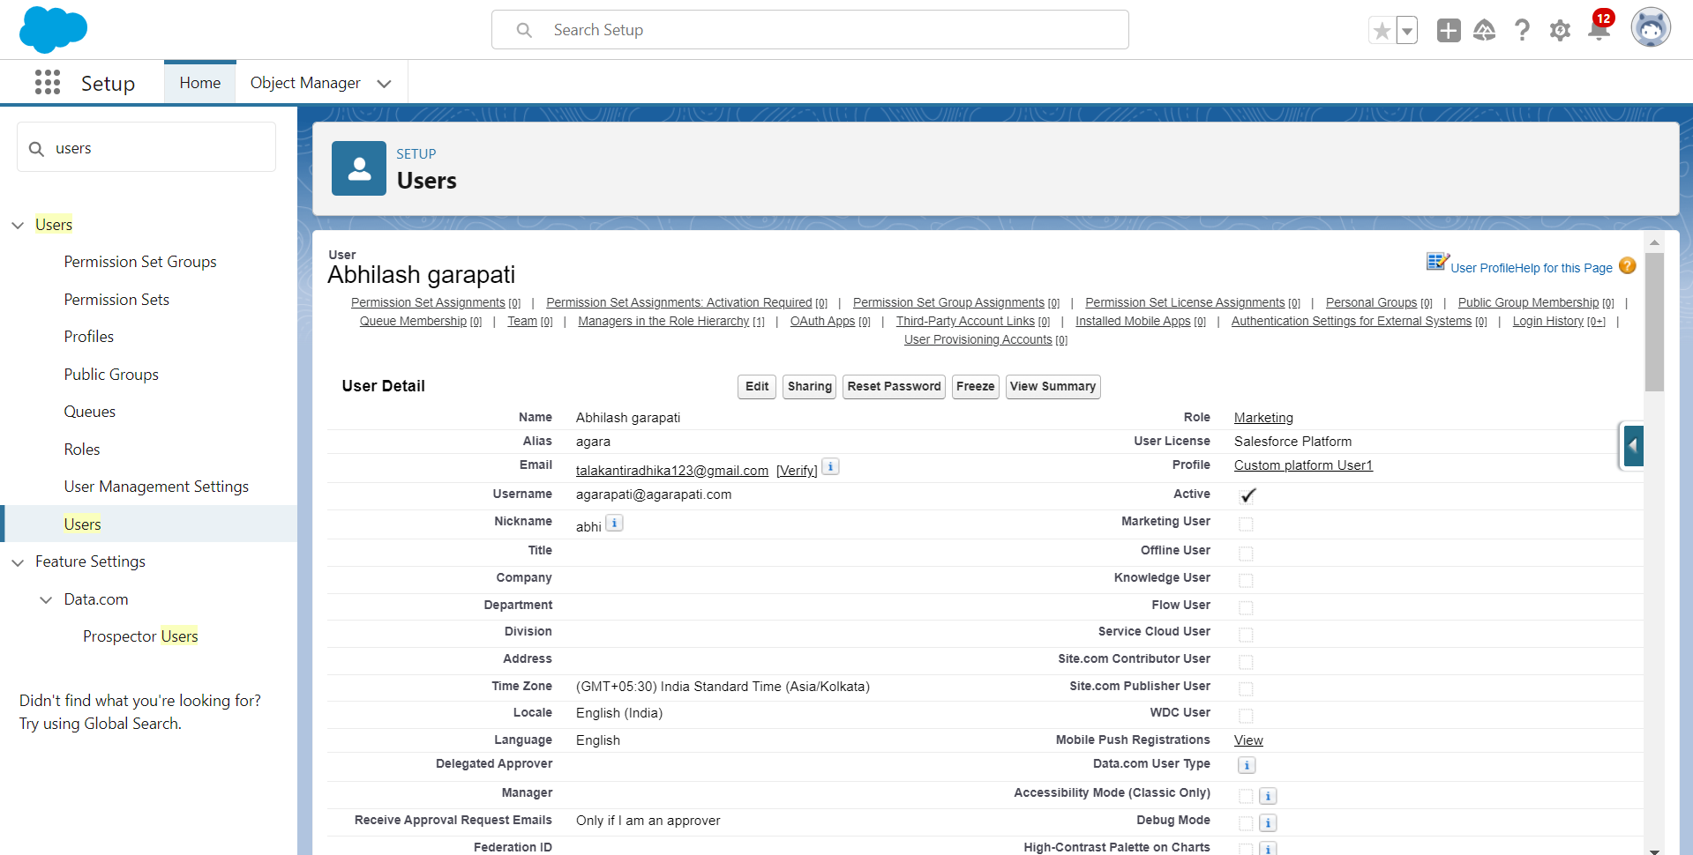

**9.3 Create Another User**

1. Go to setup > type users in quick find box > select users > click New user.
2. Fill in the fields

* First Name : Ganesh
* Last Name : gelli
* Alias : Give a Alias Name
* Email id : Give your Personal Email id
* Username : Username should be in this form: text@text.com
* Nick Name: Give a Nickname
* Role : Receptionist
* User licence: Salesforce Platform
* Profiles : Custom Platform user2

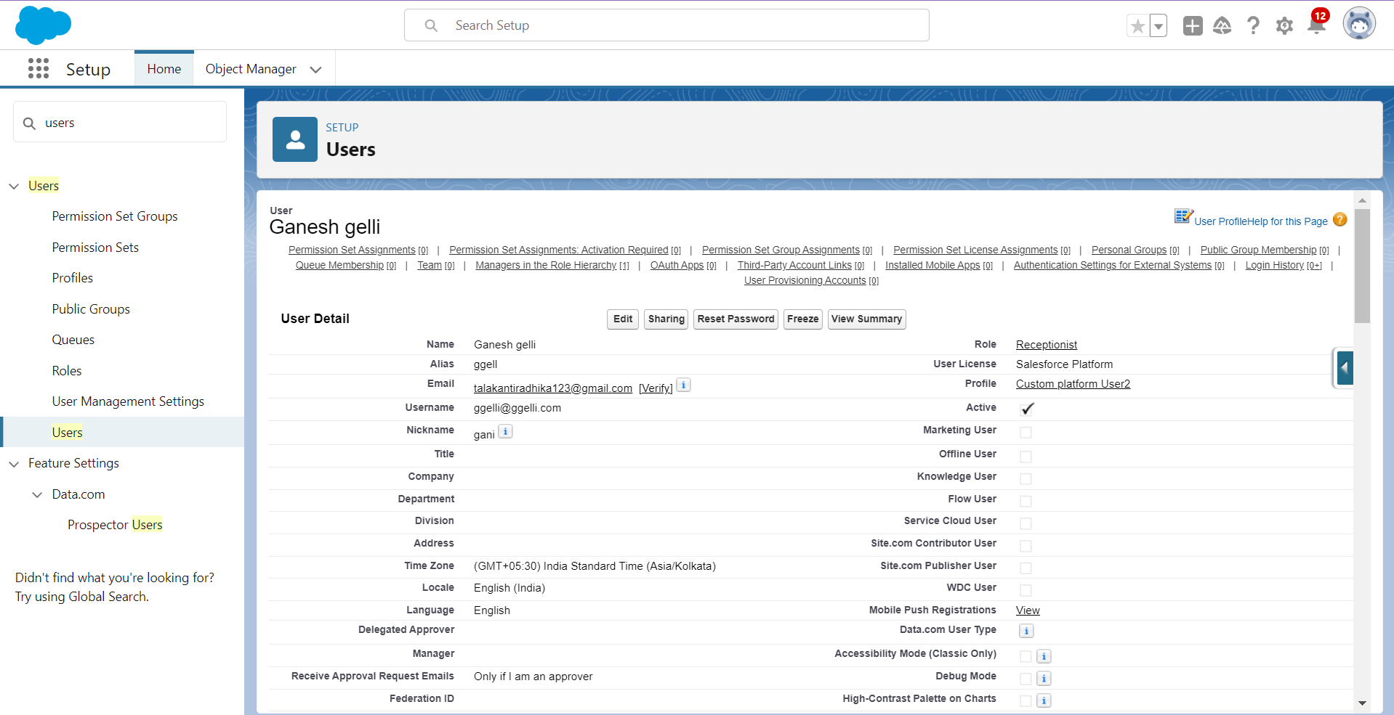

1. Save

**TASK10: User Adoption**

**10.1 Create a Record (Customers)**

1. Click on App Launcher on the left side of the screen.
2. Search The Booking Of Co-Living & click on it.
3. Click on the Customers Tab.
4. Click new and fill details & Save

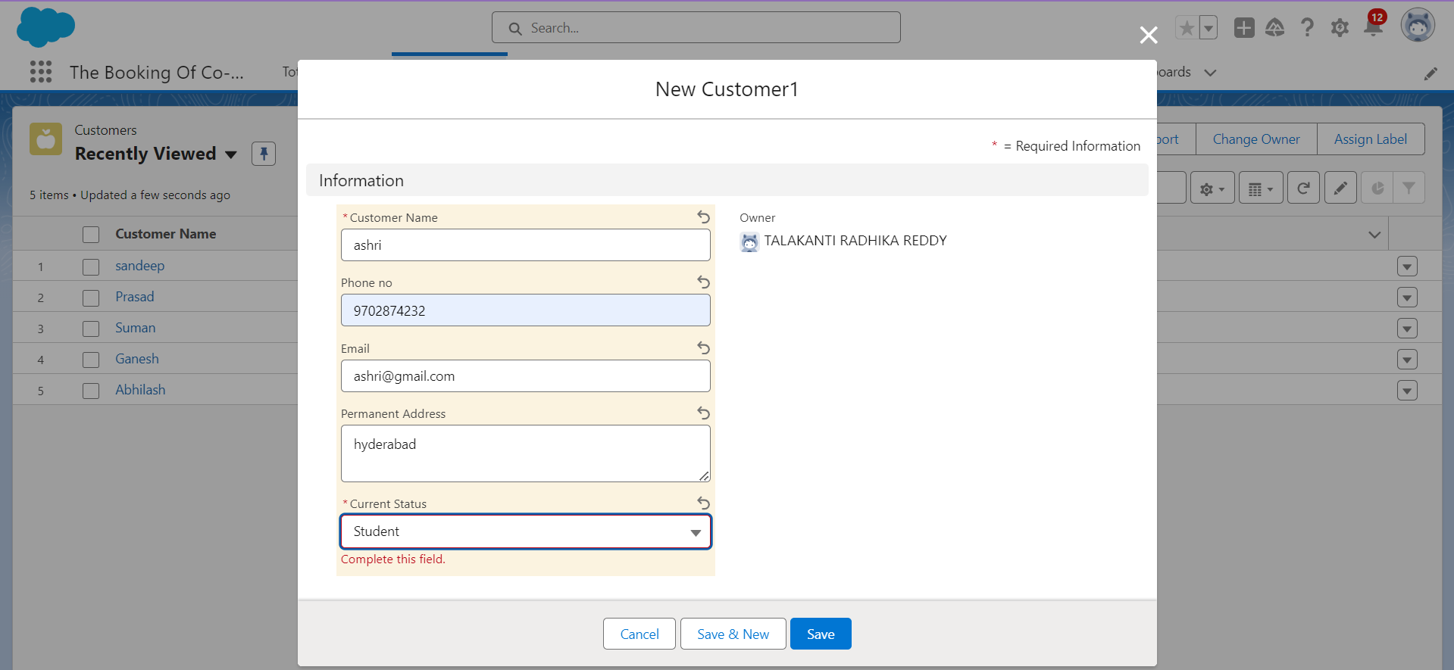

**10.2 View a Record (Customers)**

1. Click on App Launcher on the left side of the screen.
2. Search The Booking Of Co-Living & click on it.
3. Click on Customer Tab.
4. Click on any record name. you can see the details of the Customer.

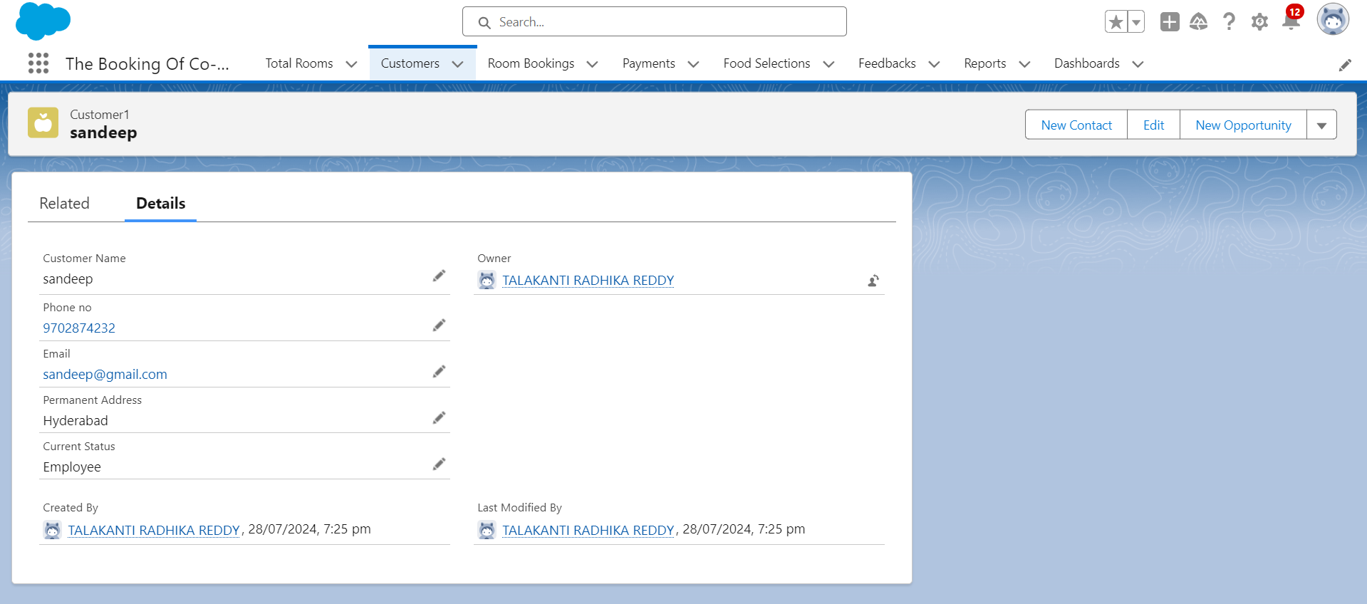

**10.3 Delete a Record (Customers)**

1. Click on App Launcher on the left side of the screen.
2. Search The Booking Of Co-Living & click on it.
3. Click on the Customers Tab.
4. Click on Arrow at right hand side on that Particular record.
5. Click delete and delete again.

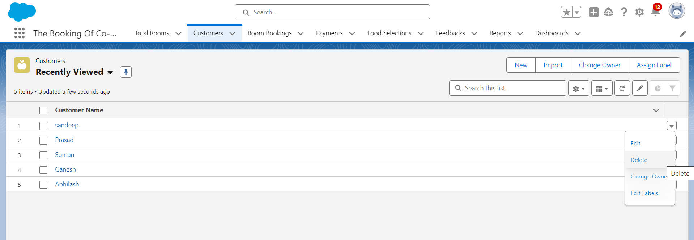

**TASK11: Reports**

Reports give you access to your Salesforce data. You can examine your Salesforce data in almost infinite combinations, display it in easy-to-understand formats, and share the resulting insights with others. Before building, reading, and sharing reports, review these reporting basics.   
Types of Reports in Salesforce

1. Tabular
2. Summary
3. Matrix
4. Joined Reports

**11.1 Create Report**

1. Go to the app > click on the reports tab
2. Click New Report.
3. Select report type from category or from report type panel or from search panel “Customers with Room Bookings with Total Rooms ” > click on start report.
4. Customize your report
5. Add fields from left pane as shown below
6. Save or run it.

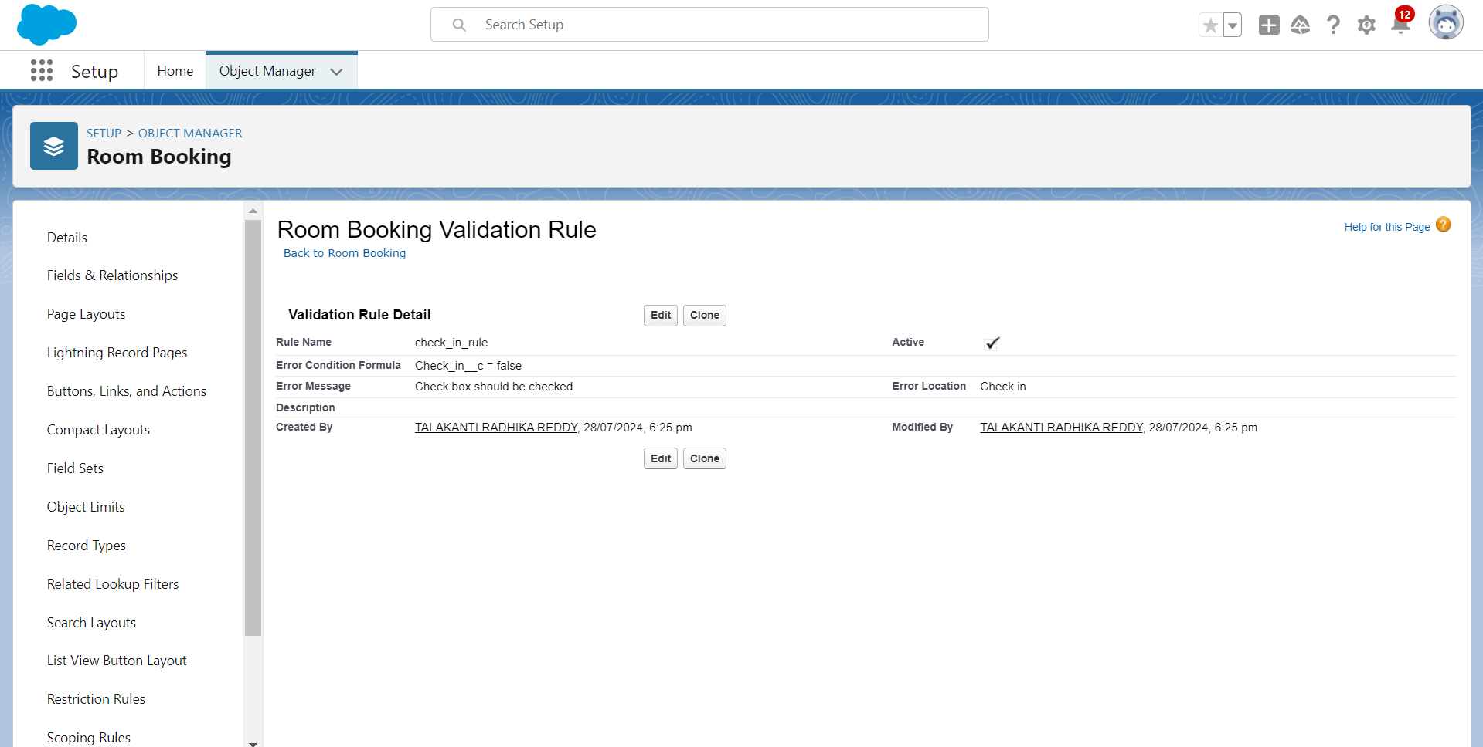

**11.2 Create Another Report**

1. Go to the app > click on the reports tab
2. Click New Report.
3. Select report type from category or from report type panel or from search panel Select “customer with Room booking with Payments” click on start report.
4. Customize your report
5. Add fields from left pane as shown Above
6. Save or run it.

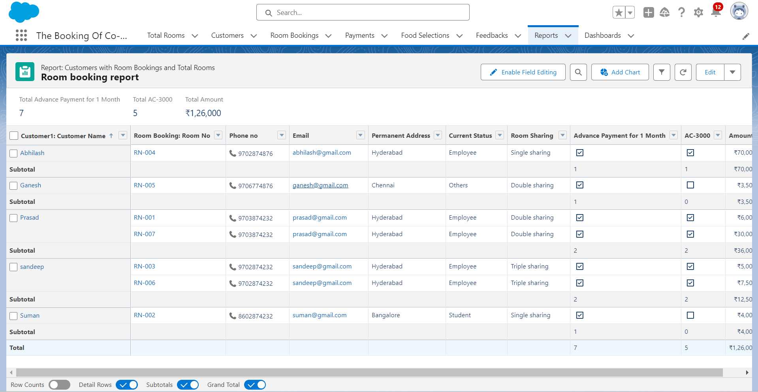

### **Taks12: Dashboards**

Dashboards help you visually understand changing business conditions so you can make decisions based on the real-time data you’ve gathered with reports. Use dashboards to help users identify trends, sort out quantities, and measure the impact of their activities. Before building, reading, and sharing dashboards, review these dashboard basics.

### **12.1 Create Dashboard**

1. Go to the app > click on the Dashboard tabs and click on new Dashboard
2. Give a Name and click on Create.
3. Select add component.
4. Select a Report Customer with Room Booking and click on select.
5. Click Add then click on Save and then click on Done.

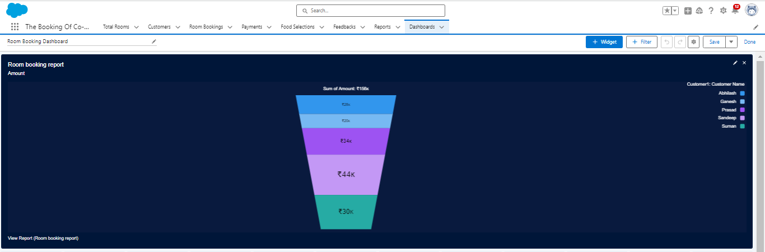

### **12.2 Create Another Dashboard**

1. Go to the app > click on the Dashboard tabs and click on new Dashboard.
2. Give a Name and click on Create.
3. Select add component.
4. Select a Report Customer with Room Booking with Payments and click on select.
5. Click Add then click on Save and then click on Done.

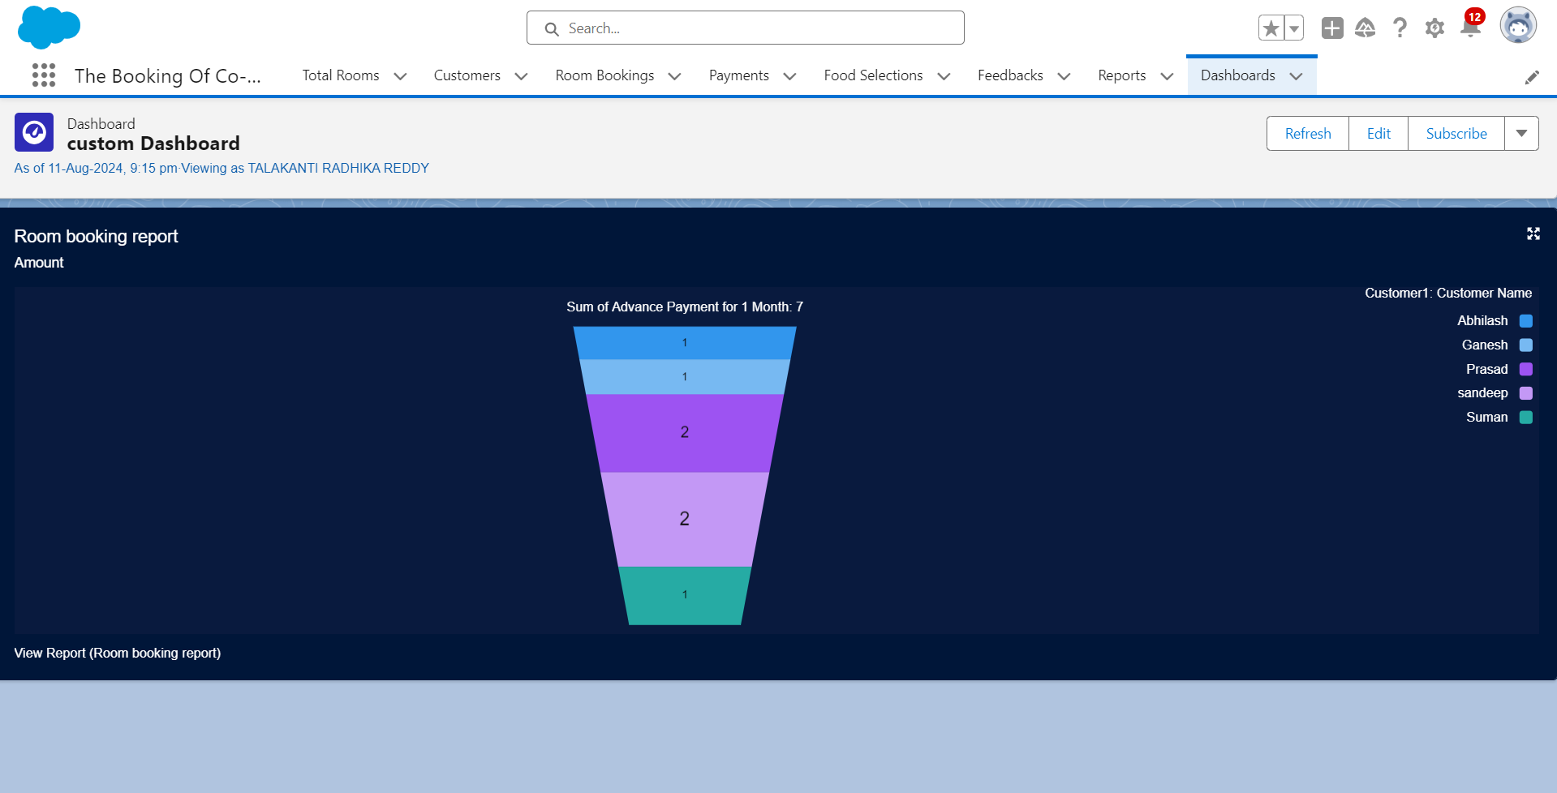

### **Task – 13: Flows**

In Salesforce, a flow is a powerful tool that allows you to automate business processes, collect and update data, and guide users through a series of screens or steps. Flows are built using a visual interface and can be created without any coding knowledge.

### **13.1. Create a Flow**

1. Go to setup > type Flow in quick find box > Click on the Flow and Select the New Flow.
2. Select the Record-triggered flow and Click on Create.
3. Select the Object as a Room Booking in the Drop down list.
4. Select the Trigger Flow when: “A record is Created or Updated”.
5. Select the Optimize the flow for: “Actions and Related Records” and Click on Done.
6. Under the Record-triggered Flow Click on “+” Symbol and In the Drop down List select the “Decision Element”.
7. Enter the Details Label: Field should be Update, API name: Gets Automatically Generated.
8. Enter the Outcome Details Label: Single sharing, Outcome API name: Gets Automatically Generated.

* Resource: Select Record.Room sharing.
* Operator: Select Equals.
* Value: Select Single sharing.
* Click on “Add Condition”
* Resource: Select Record.AC-3000.
* Operator: Select Equals.
* Value: Select False.
* Click on “+” Symbol In the Outcome Order.

9. Enter the Outcome Details Label: Double sharing, Outcome API name: Gets Automatically Generated.

* Resource: Select Record.Room sharing.
* Operator: Select Equals.
* Value: Select Double sharing.
* Click on “Add Condition”
* Resource: Select Record.AC-3000.
* Operator: Select Equals.
* Value: Select False.
* Click on “+” Symbol In the Outcome Order.

10. Enter the Outcome Details Label: Triple sharing, Outcome API name: Gets Automatically Generated.

* Resource: Select Record.Room sharing.
* Operator: Select Equals.
* Value: Select Triple sharing.
* Click on “Add Condition”
* Resource: Select Record.AC-3000.
* Operator: Select Equals.
* Value: Select False.
* Click on “+” Symbol In the Outcome Order.

11. Enter the Outcome Details Label: Single Ac, Outcome API name: Gets Automatically Generated.

* Resource: Select Record.Room sharing.
* Operator: Select Equals.
* Value: Select Single sharing.
* Click on “Add Condition”
* Resource: Select Record.AC-3000.
* Operator: Select Equals.
* Value: Select True.
* Click on “+” Symbol In the Outcome Order.

12. Enter the Outcome Details Label: Double Ac, Outcome API name: Gets Automatically Generated.

* Resource: Select Record.Room sharing.
* Operator: Select Equals.
* Value: Select Double sharing.
* Click on “Add Condition”
* Resource: Select Record.AC-3000.
* Operator: Select Equals.
* Value: Select True.
* Click on “+” Symbol In the Outcome Order.

13. Enter the Outcome Details Label: Triple Ac, Outcome API name: Gets Automatically Generated.

* Resource: Select Record.Room sharing.
* Operator: Select Equals.
* Value: Select Triple sharing.
* Click on “Add Condition”
* Resource: Select Record.AC-3000.
* Operator: Select Equals.
* Value: Select True.
* Click on Done.

14. Click on “+” Symbol under the single sharing and Select the “update Records" in the drop down list.

15. Enter the update records details

* Label: Single.
* API name: Gets automatically Generated.
* Under the Set Field Values for the Room Booking Record.
* Field: Amount.
* Value: 28000.
* Click on Done.

16. Enter the update records details

* Label: Double.
* API name: Gets automatically Generated.
* Under the Set Field Values for the Room Booking Record.
* Field: Amount.
* Value: 24000.
* Click on Done.

17. Enter the update records details

* Label: Triple.
* API name: Gets automatically Generated.
* Under the Set Field Values for the Room Booking Record.
* Field: Amount.
* Value: 20000.
* Click on Done.

18. Enter the update records details

* Label: Single ac1.
* API name: Gets automatically Generated.
* Under the Set Field Values for the Room Booking Record.
* Field: Amount.
* Value: 34000.
* Click on Done.

19. Enter the update records details

* Label: Double ac1.
* API name: Gets automatically Generated.
* Under the Set Field Values for the Room Booking Record.
* Field: Amount.
* Value: 30000.
* Click on Done.

20. Enter the update records details

* Label: Triple ac1.
* API name: Gets automatically Generated.
* Under the Set Field Values for the Room Booking Record.
* Field: Amount.
* Value: 26000.
* Click on Done.

21. The Flow will Form like This and Click on save.

22. Enter the Flow Label: Update Amount Field, Flow API Name: Gets Automatically Generated and Click on Save.

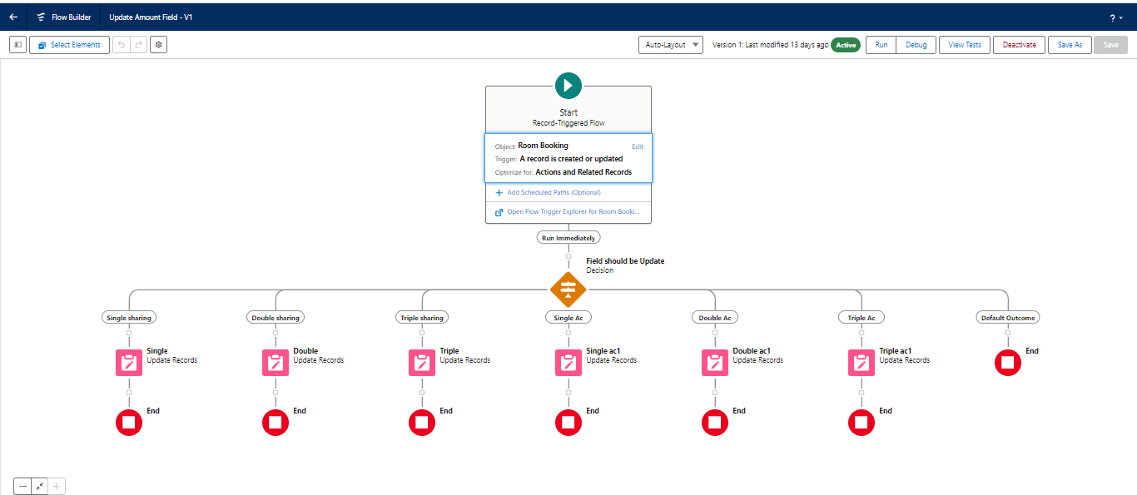

### **13.2. Test the Flow**

1. Go to App Launcher and search for The Booking of Co-living and select the app
2. In the Co-living app click on the Room sharing tab and click on new.
3. Enter the details like Name, Room sharing, Ac-3000, Advance payment for 1 Month. And the Amount field is empty before saving the record.

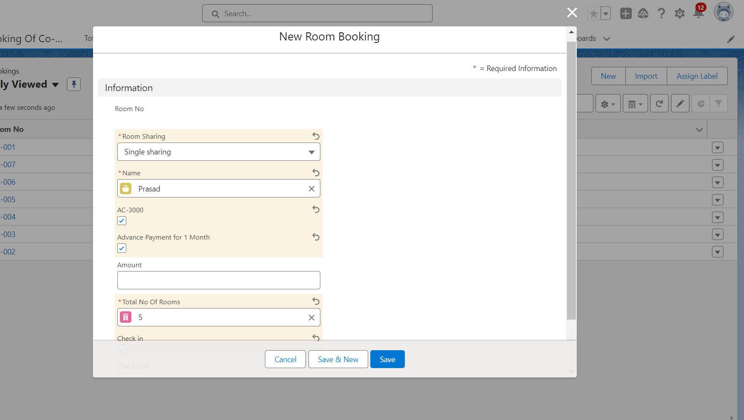

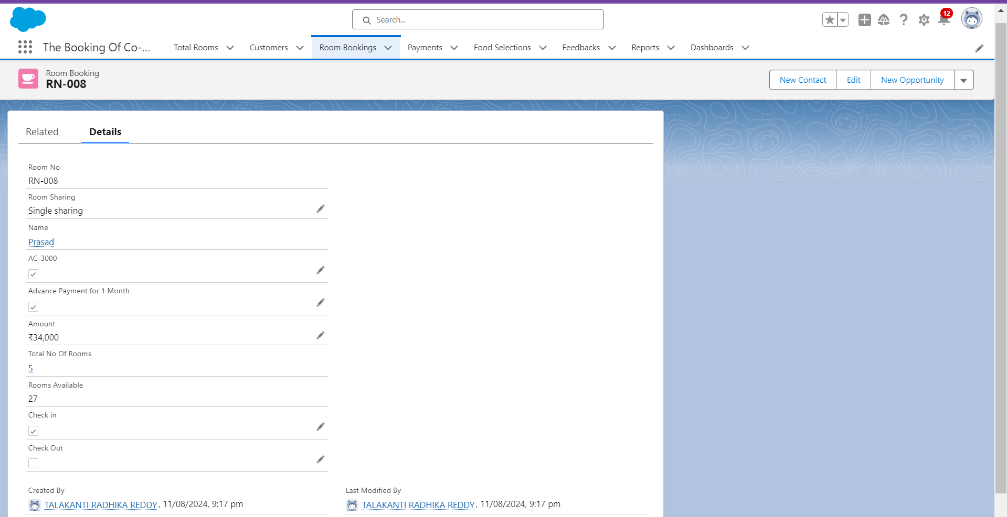

    4. After saving the record the amount gets reflected in the Amount field by using the given flows.

**Conclusion**

The Co-Living Space project effectively delivers a comprehensive CRM platform tailored for managing the various aspects of a co-living environment. The application streamlines room selection, personalized meal planning, payment processing, and service feedback, making it easier for residents to manage their stay while enhancing their overall living experience.

By fostering community interaction and encouraging shared responsibility, the platform not only promotes a sense of belonging but also ensures that residents' needs are promptly addressed. This project successfully combines convenience, comfort, and community, providing a well-rounded solution for modern co-living spaces.